
It Came Upon the Midnight Clear
C31 C
Lyrics by Edmund Sears (1849); Tune of "Carol" by Richard Storrs Willis (1850)

Intro (Chords of last line of verse)  C F C  It came u-pon the midnight clear,  F D7 G - G7  That glorious song of old,  C F C  From angels bending near the earth  F G7 C  To touch their harps of gold!  E7 Am  Peace on the earth, good will to men,  G D7 G - G7  From heaven's all gracious King!  C F C  The world in solemn stillness lay  F G7 C  To hear the angels sing.  C F C  Still through the cloven skies they come  F D7 G - G7  With peaceful wings unfurled  C F C  And still their heavenly music floats  F G7 C  O'er all the weary world;  E7 Am  A-bove its sad and lowly plains  G D7 G - G7  They bend on hovering wing.  C F C  And ever o'er its Babel sounds  F G7 C  The blessed angels sing. |  |  |  |  | C F C  Yet with the woes of sin and strife  F D7 G - G7  The world hath suffered long;  C F C  Be-neath the angel-strain have rolled  F G7 C  Two thousand years of wrong;  E7 Am  And man, at war with man, hears not  G D7 G - G7  The love song which they bring:  C F C  O hush the noise, ye men of strife,  F G7 C  And hear the angels sing.  C F C  For lo! The days are hastening on,  F D7 G - G7  By prophet bards fore-told,  C F C  When, with the ever-circling years,  F G7 C  Shall come the Age of Gold;  E7 Am  When peace shall over all the earth  G D7 G - G7  Its ancient splendors fling,  C F C  And all the world give back the song  F G7 C  Which now the angels sing.
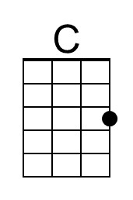 | 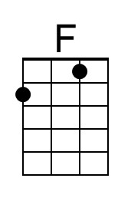 | 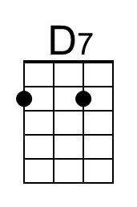 | 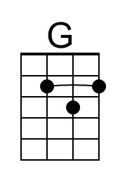 | 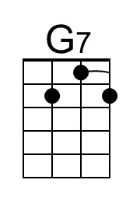 |  | 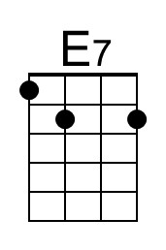 | 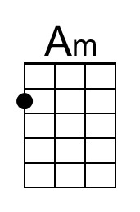
Baritone | 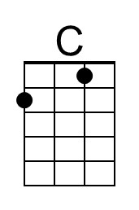 | 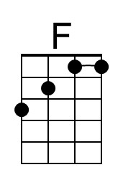 | 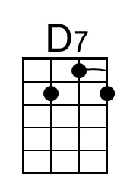 | 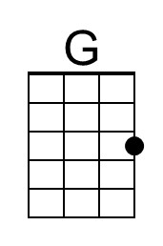 |  | 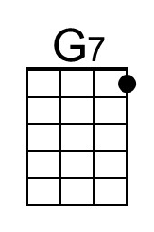 | 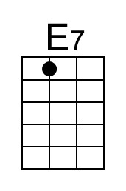 | 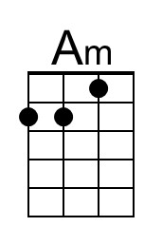

It Came Upon the Midnight Clear
C31 G
Lyrics by Edmund Sears (1849); Tune of "Carol" by Richard Storrs Willis (1850)

Intro (Chords of last line of verse)  G C G  It came u-pon the midnight clear,  C A7 D - D7  That glorious song of old,  G C G  From angels bending near the earth  C D7 G  To touch their harps of gold!  B7 Em  Peace on the earth, good will to men,  D A7 D - D7  From heaven's all gracious King!  G C G  The world in solemn stillness lay  C D7 G  To hear the angels sing.  G C G  Still through the cloven skies they come  C A7 D - D7  With peaceful wings un-furled  G C G  And still their heavenly music floats  C D7 G  O'er all the weary world;  B7 Em  A-bove its sad and lowly plains  D A7 D - D7  They bend on hovering wing.  G C G  And ever o'er its Babel sounds  C D7 G  The blessed angels sing. |  |  |  |  | G C G  Yet with the woes of sin and strife  C A7 D - D7  The world hath suffered long;  G C G  Be-neath the angel-strain have rolled  C D7 G  Two thousand years of wrong;  B7 Em  And man, at war with man, hears not  D A7 D - D7  The love song which they bring:  G C G  O hush the noise, ye men of strife,  C D7 G  And hear the angels sing.  G C G  For lo! The days are hastening on,  C A7 D - D7  By prophet bards fore-told,  G C G  When, with the ever-circling years,  C D7 G  Shall come the Age of Gold;  B7 Em  When peace shall over all the earth  D A7 D - D7  Its ancient splendors fling,  G C G  And all the world give back the song  C D7 G  Which now the angels sing.
 |  | 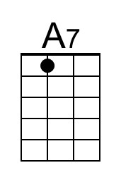 | 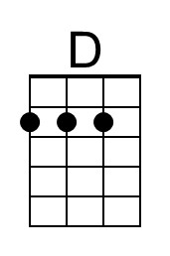 |  |  | 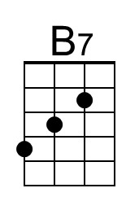 | 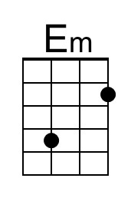
Baritone |  |  | 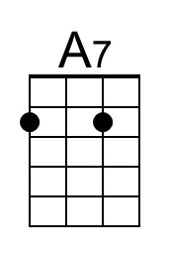 | 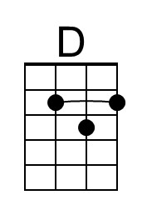 |  |  | 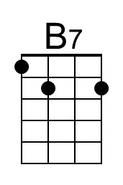 | 