**It Came Upon the Midnight Clear**

C 31

**C F C**

It came upon the midnight clear,

**F D7 G G7**

That glorious song of old,

**C F C**

From angels bending near the earth

**F G7 C**

To touch their harps of gold!

**E7 Am**

Peace on the earth, good will to men,

**G D7 G G7**

From heaven's all gracious King!

**C F C**

The world in solemn stillness lay

**F G7 C**

To hear the angels sing.

**C F C**

Still through the cloven skies they come

**F D7 G G7**

With peaceful wings unfurled

**C F C**

And still their heavenly music floats

**F G7 C**

O'er all the weary world;

**E7 Am**

Above its sad and lowly plains

**G D7 G G7**

They bend on hovering wing.

**C F C**

And ever o'er its Babel sounds

**F G7 C**

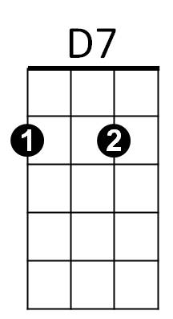The blessed angels sing.



G

F



C

**BARITONE**

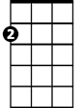

Am

E7

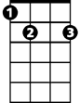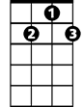

G7

**C F C**

Yet with the woes of sin and strife

**F D7 G G7**

The world hath suffered long;

**C F C**

Beneath the angel-strain have rolled

**F G7 C**

Two thousand years of wrong;

**E7 Am**

And man, at war with man, hears not

**G D7 G G7**

The love song which they bring:

**C F C**

O hush the noise, ye men of strife,

**F G7 C**

And hear the angels sing.

**C F C**

For lo! The days are hastening on,

**F D7 G G7**

By prophet bards foretold,

**C F C**

When, with the ever-circling years,

**F G7 C**

Shall come the Age of Gold;

**E7 Am**

When peace shall over all the earth

**G D7 G G7**

Its ancient splendors fling,

**C F C**

And all the world give back the song

**F G7 C**

Which now the angels sing

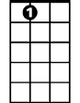

E7

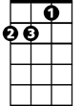

Am



D7



F

C



G

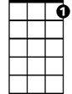

G7