**It Doesn’t Matter Anymore**

**INTRO: C**

**C**

There you go and baby, here am I.

**G7**

Well, you left me here so I could sit and cry.

**C**

Well, golly gee, what have you done to me?

**G7 C**

I guess it doesn't matter any more

**C**

Do you remember baby, last September

**G7**

How you held me tight, each an d every night

**C**

Well, oh baby, how you drove me crazy

**G7 C**

I guess it doesn't matter any more



C

**Chorus:**

**Am**

There's no use in me a-cryin'.

**C**

I've done everything and I'm sick of tryin'.

**D7**

I've thrown away my nights,

**G7 F C G7**

Wasted all my days over you

**BARITONE**

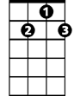

D7

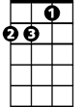

Am

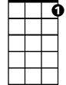

G7

C



**C**

Now you go your way and I'll go mine

**G7**

Now and forever till the end of time

**C**

I'll find somebody new and baby, we'll say we're through

**G7 C**

And you won't matter any more

**BREAK: C G7 C G7 C (Verse melody)**

**(Repeat from Chorus)**

**G7 C**

No you won't matter any more

**G7 C**

You won't matter any more

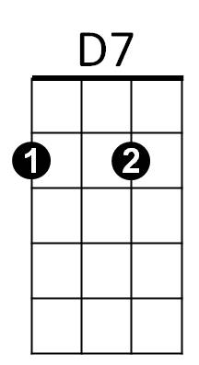

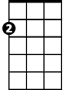

Am



G7

F



F

**It Doesn’t Matter Anymore**

**INTRO: F**

**F**

There you go and baby, here am I.

**C7**

Well, you left me here so I could sit and cry.

**F**

Well, golly gee, what have you done to me?

**C7 F**

I guess it doesn't matter any more

**F**

Do you remember baby, last September

**C7**

How you held me tight, each and every night

**F**

Well, oh baby, how you drove me crazy

**C7 F**

I guess it doesn't matter any more

**Chorus:**

**Dm**

There's no use in me a-cryin'.

**F**

I've done everything and I'm sick of tryin'.

**G7**

I've thrown away my nights,

**C7 Bb F C7**

Wasted all my days over you

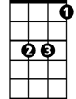

Bb

**BARITONE**

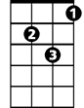

Dm



G7

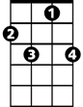

C7



F

**F**

Now you go your way and I'll go mine

**C7**

Now and forever till the end of time

**F**

I'll find somebody new and baby, we'll say we're through

**C7 F**

And you won't matter any more

**BREAK: F C7 F C7 F (Verse melody)**

**(Repeat from Chorus)**

**C7 F**

No you won't matter any more

**C7 F**

You won't matter any more



Bb



G7



Dm



C7

F

