**It Doesn’t Matter Anymore (Paul Anka)**

**C**

There you go, and baby, and here am I.

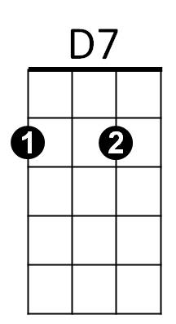 **G7**

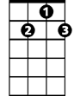

G7

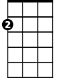

Am



G

F



C

Well, you left me here so I could sit and cry.

**C**

Well, golly gee, what have you done to me?

**G7 C**

Well, I guess it doesn't matter anymore.

**C**

Do you remember, baby, last September

**G7**

How you held me tight each and every night?

**C**

Oh, baby, how you drove me crazy!

**G7 C**

But I guess it doesn't matter anymore

**Chorus**



G



F

C

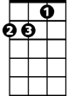

Am

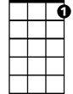

G7

**BARITONE**



D7

**Am**

There is no use in me a-cryin',

**C**

I've done everything and I'm sick of tryin'.

**D7**

I've thrown away my nights,

**G7 F C G**

And wasted all my days over you

**C**

Now, you go your way, baby, and I'll go mine

**G7**

Now and forever till the end of time

**C**

I'll find somebody new, and baby, we'll say we're through

**G7 C**

And you won't matter any more

**Repeat from Chorus**

**G7 C (2X)**

And you won't matter any more