**It Never Rains in Southern California (Albert Hammond / Mike Hazlewood) Key C**

**Dm G C 2x**

**C Dm G C**

Got on a board a westbound 7 - forty- 7

**Dm G C**

Didn't think before deciding what to do

**Dm G**

All that talk of oppor-tunities,

**C Am**

TV breaks and movies

**Dm G C**

Rang true, sure rang true.

**Chorus:**

**TACET Dm G C Am**

Seems it never rains in Southern California

**Dm G C**

Seems I've often heard that kind of talk before

**C7 Dm G**

It never rains in California

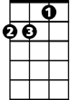

Dm

**C Am**

But girls, don't they warn ya

**Dm G C**

It pours - man, it pours.

**TACET Dm G**

Out of work, I'm out of my head

**C**

Out of self respect, I'm out of bread

**Dm G**

**BARITONE**

I'm under loved, I'm under fed

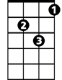

Dm

**C C7**

I wanna go home

**Dm G**

It never rains in California

**C Am**

But girls, don't they warn ya

**Dm G C**

It pours - man, it pours.

**Dm G C**

**TACET Dm G**

Will you tell the folks back home

**C**

I nearly made it

**Dm G C**

Had offers but don't know which one to take

**Dm G**

Please don't tell them how you found me

**C Am**

Don't tell them how you found me,

**Dm G C**

Give me a break - give me a break

**(Chorus)**



C



G

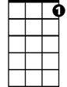

C7

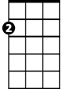

Am



Am

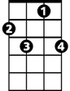

C7

C



G

**It Never Rains in Southern California (Albert Hammond / Mike Hazlewood) Key G**

**Am D G 2x**

**G Am D G**

Got on a board a westbound 7 - forty- 7

**Am D G**

Didn't think before deciding what to do

**Am D**

All that talk of oppor-tunities,

**G Em**

TV breaks and movies

**Am D G**

Rang true, sure rang true.

**Chorus:**

**TACET Am D G Em**

Seems it never rains in Southern California

**Am D G**

Seems I've often heard that kind of talk before

**G7 Am D**

It never rains in California



Am

**G Em**

But girls, don't they warn ya

**Am D G**

It pours - man, it pours.

**TACET Am D**

Out of work, I'm out of my head

**G**

Out of self respect, I'm out of bread

**Am D**

I'm under loved, I'm under fed



Am

**G G7**

I wanna go home

**Am D**

It never rains in California

**G Em**

But girls, don't they warn ya

**Am D G**

It pours - man, it pours.

**Am D G**

**TACET Am D**

Will you tell the folks back home

**G**

I nearly made it

**Am D G**

Had offers but don't know which one to take

**Am D**

Please don't tell them how you found me

**G Em**

Don't tell them how you found me,

**Am D G**

Give me a break - give me a break

**(Chorus)**

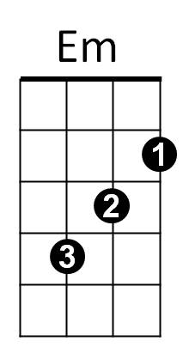

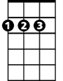

D



G

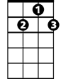

G7

**BARITONE**



G



Em



G7



D