It’s Beginning to Look A Lot Like Christmas
C72 C
(Meredith Willson, 1951) – It’s Beginning To Look A Lot Like Christmas by Perry Como

Intro Dm7 G7 C G7  C F C E7 F A7  It’s be-ginning to look a lot like Christmas, ev’ry-where you go.  Dm7 G7 Em Am  Take a look in the five and ten, glistening once a-gain,  G D7 G7  With candy canes and silver lanes a-glow.  C F C E7 F A7  It’s be-ginning to look a lot like Christmas, toys in ev’ry store.  Dm7 C#dim7 C A7  But the prettiest sight to see is the holly that will be  Dm7 G7 C  On your own front door.  Bridge  E7  A pair of Hopalong boots and a pistol that shoots  Am E7 Am  Is the wish of Barney and Ben,  A7  Dolls that will talk and will go for a walk  G7 D7 G7  Is the hope of Janice and Jen,  G G7  And Mom and Dad can hardly wait for school to start again.  C F C E7 F A7  It’s be-ginning to look a lot like Christmas, ev’ry-where you go.  Dm7 G7 Em Am  There’s a tree in the Grand Ho-tel, one in the park as well,  G D7 G7  The sturdy kind that doesn’t mind the snow.  C F C E7 F A7  It’s be-ginning to look a lot like Christmas, soon the bells will start.  Dm7 C#dim7 C A7  And the thing that will make them ring is the carol that you sing,  Dm7 G7 C A7  Right with-in your heart.  Repeat 2nd Verse  Outro 1 Dm7 G7 C Sure, it’s Christmas once more. Outro 2 Dm7 G7 C Right with - in your heart. | 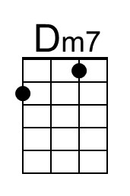 | 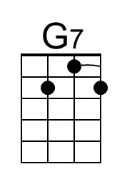 | 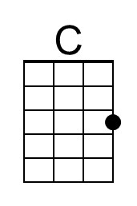
 | 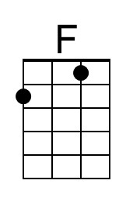 | 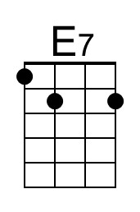 | 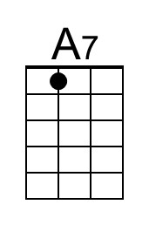
 | 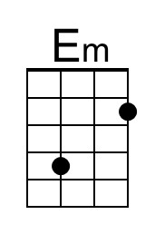 | 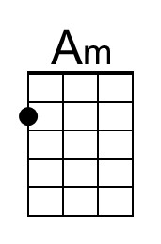 | 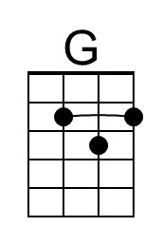
 | 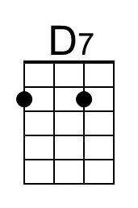 | 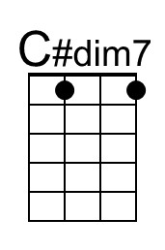
 | Baritone
 | 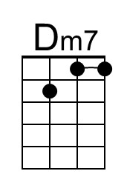 | 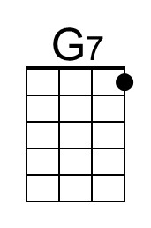 | 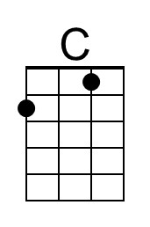
 | 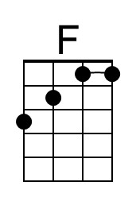 | 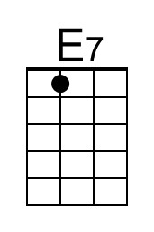 | 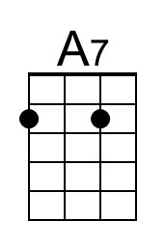
 | 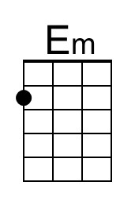 | 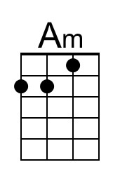 | 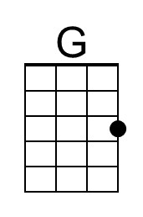
 | 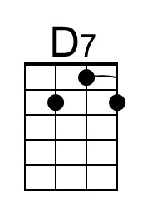 | 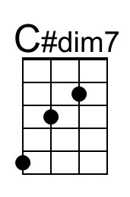

It’s Beginning to Look A Lot Like Christmas
C72 G
(Meredith Willson, 1951) – It’s Beginning To Look A Lot Like Christmas by Perry Como

Intro Am7 D7 G D7  G C G B7 C E7  It’s be-ginning to look a lot like Christmas, ev’ry-where you go.  Am7 D7 Bm Em  Take a look in the five and ten, glistening once a-gain,  D A7 D7  With candy canes and silver lanes a-glow.  G C G B7 C E7  It’s be-ginning to look a lot like Christmas, toys in ev’ry store.  Am7 G#dim7 G E7  But the prettiest sight to see is the holly that will be  Am7 D7 G  On your own front door.  Bridge  B7  A pair of Hopalong boots and a pistol that shoots  Em B7 Em  Is the wish of Barney and Ben,  E7  Dolls that will talk and will go for a walk  D7 A7 D7  Is the hope of Janice and Jen,  D D7  And Mom and Dad can hardly wait for school to start again.  G C G B7 C E7  It’s be-ginning to look a lot like Christmas, ev’ry-where you go.  Am7 D7 Bm Em  There’s a tree in the Grand Ho-tel, one in the park as well,  D A7 D7  The sturdy kind that doesn’t mind the snow.  G C G B7 C E7  It’s be-ginning to look a lot like Christmas, soon the bells will start.  Am7 G#dim7 G E7  And the thing that will make them ring is the carol that you sing,  Am7 D7 G E7  Right with-in your heart.  Repeat 2nd Verse  Outro 1 Am7 D7 G Sure, it’s Christmas once more. Outro 2 Am7 D7 G Right with - in your heart. | 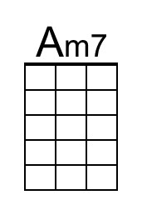
 |  | 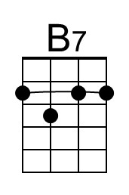
 | 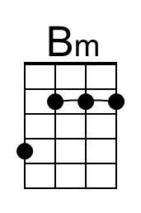 |  | 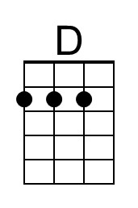
 |  | 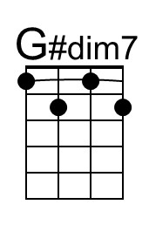
 | Baritone
 | 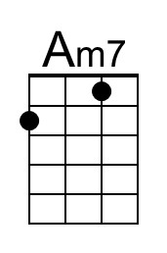
 |  | 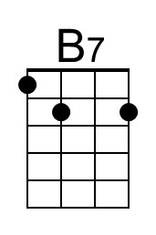
 | 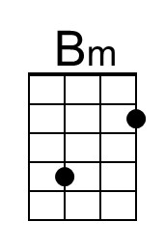 |  | 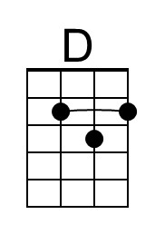
 |  | 