It's Alright (Mike Moran, 2004) (C)

C G C G  It's alright it's ok, doesn't really matter if you're old and gray.  C G C  It's alright, I say it's ok, listen to what I say.  C G C G  It's alright doing fine, doesn't really matter if the sun don't shine.  C G C  It's alright I say it's ok. We're getting to the end of the day.  Chorus  F C  High tech, low tech, take your pick  G C  You can't teach an old dog a brand new trick.  F C G  I don't care what anybody says (at the end of the day)  Bridge  G C  There's a place I can't find  F G C  A drink or two to ease my mind.  G  Golden days  C G C G  It's alright take your time, everybody thinks that you've passed your prime.  C G C  It's alright it's ok, you've still got plenty to say.  Instrumental Outro: C F C G C F G C | 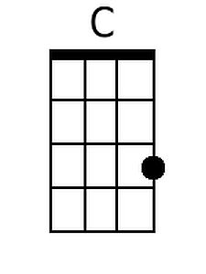
 | 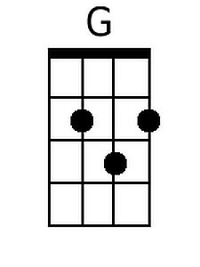
 | 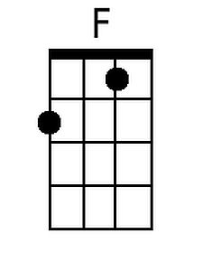
 | Bari
 | 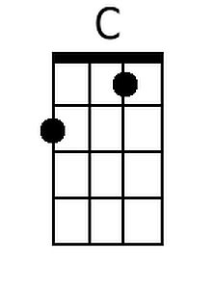
 | 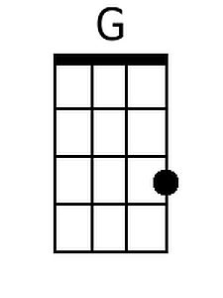
 | 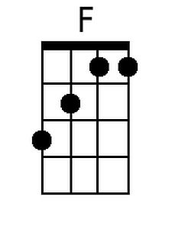

Notes:
- The bridge isn't played during the opening credits of the show so you'll need to listen to an extended version of the song to get melody.
- The extended version treats the Instrumental Outro as an Instrumental Break before repeating the song from the top.

It's Alright (Mike Moran, 2004) (G)

G D G D
It's alright, it's ok, doesn't really matter if you're old and gray.
G D G
It's alright, I say it's ok, listen to what I say.

G D G D
It's alright doing fine, doesn't really matter if the sun don't shine.
G D G
It's alright I say it's ok. We're getting to the end of the day.

Chorus
C G
High tech, low tech, take your pick
D G
You can't teach an old dog a brand new trick.
C G D
I don't care what anybody says (at the end of the day)

Bridge
D G
There's a place I can't find
C D G
A drink or two to ease my mind.
D
Golden days

G D G D
It's alright take your time, everybody thinks that you've passed your prime.
G D G
It's alright it's ok, you've still got plenty to say.

Instrumental Outro: G C G D G C D G
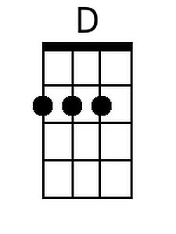
Bari
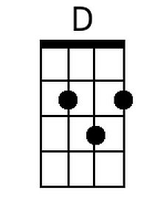

Notes:
- The bridge isn't played during the opening credits of the show so you'll need to listen to an extended version of the song to get melody.
- The extended version treats the Instrumental Outro as an Instrumental Break before repeating the song from the top.
It's Alright (Mike Moran, 2004) (NN)

1 5 1 5  It's alright, it's ok, doesn't really matter if you're old and gray.  1 5 1  It's alright, I say it's ok, listen to what I say.  1 5 1 5  It's alright doing fine, doesn't really matter if the sun don't shine.  1 5 1  It's alright I say it's ok. We're getting to the end of the day. | 1 | 4 | 5
 | A | D | E
 | C | F | G
 | D | G | C
 | F | Bb | C
 | G | C | D

Chorus
4 1
High tech, low tech, take your pick
5 1
You can't teach an old dog a brand new trick.
4 1 5
I don't care what anybody says (at the end of the day)

Bridge
5 1
There's a place I can't find
4 5 1
A drink or two to ease my mind.
5
Golden days

1 5 1 5
It's alright take your time, everybody thinks that you've passed your prime.
1 5 1
It's alright it's ok, you've still got plenty to say.

Instrumental Outro: 1 4 1 5 1 4 5 1

Notes:
- The bridge isn't played during the opening credits of the show so you'll need to listen to an extended version of the song to get melody.
- The extended version treats the Instrumental Outro as an Instrumental Break before repeating the song from the top.

