**It’s In His Kiss (Rudy Clark)**

**G (single strum) F (single strum)**

Does he love me? I want to know

**G (single strum)**

How can I tell if he loves me so?

**F G**

(Is it in his eyes?) Oh no, you’ll be deceived

**F G**

(Is it in his eyes?) Oh no, he’ll make believe

**C Am**

If you want to know

(Shoop, shoop, shoop, shoop)

**F G**

If he loves you so

(Shoop, shoop, shoop, shoop)

**C F G**

It’s in his kiss (That’s where it is)

**F G**

(Or is it in his face?) Oh no, it's just his charms

**F G**

(In his warm embrace?) Oh no, that’s just his arms

**C Am**

If you want to know

(Shoop, shoop, shoop, shoop)

**F G**

If he loves you so

(Shoop, shoop, shoop, shoop)

**C F G**

It’s in his kiss (That’s where it is)

**C F C**

Oh, it’s in his kiss, that’s where it is

**Reprise:**

**E7**

Woah-oh-oh, hug him and squeeze him tight

**Am**

Find out what you want to know

**D7 G**

If it’s love, if it really is, it’s there in his kiss



F



G

**F G**

(About the way he acts) Oh no, thats not the way

**F G**

And you’re not listening to all I say

**C Am**

If you want to know

(Shoop, shoop, shoop, shoop)

**F G**

If he loves you so

(Shoop, shoop, shoop, shoop)

**C F G**

It’s in his kiss (That’s where it is)

**C F C**

Oh, it’s in his kiss, that’s where it is

**(Repeat from Reprise, end chorus with G)**

**G C F G**

Oh yeah, it’s in his kiss, that’s where it is

**(Repeat to fade)**

**C F G**

It’s in his kiss, that’s where it is

F



C



G

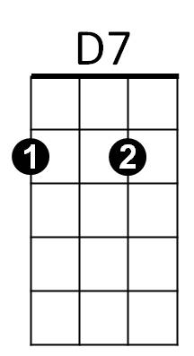

**BARITONE**

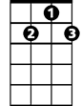

D7

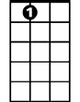

E7

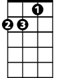

Am

C

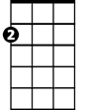

Am

E7

