**It's Raining Men (Paul Jabara / Paul Shaffer / Bob Esty)**

**Intro: Em G C B**

**Em**

Humidity is rising - Barometer's getting low

According to our sources,

**B7**

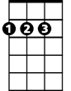

D



C

Em

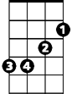

G

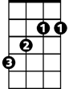

B

The street's the place to go

**Em**

Cause tonight for the first time

**Am**

Just about half -past ten

**B**

For the first time in history

**B7**

It's gonna start raining men.

**C D**

It's Raining Men! Hallelujah! –

**B Em**

It's Raining Men! Amen!

**Am**

I'm gonna go out to run and let myself get

**B B7**

Absolutely soaking wet!

**C D**

It's Raining Men! Hallelujah! –

**B Em**

It's Raining Men! Every Spe-ci-men!

**Am**

Tall, blonde, dark and lean

**B B7**

Rough and tough and strong and mean

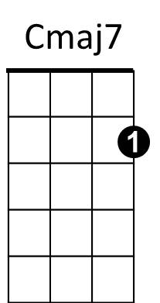

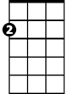

Am

**Cmaj7 D**

God bless Mother Nature,

**B7 Em**

She's a single woman too

**Cmaj7 D**

She took from the heavens

**B7 Em**

And she did what she had to do

**Cmaj7 D B7 Em**

She taught every angel to rearrange the sky

**C**

C



B

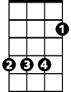

So that each and every woman

**B7**

Could find her perfect guy

**C D**

It's Raining Men! Hallelujah! –

**B Em**

It's Raining Men! Amen!

**C D**

It's Raining Men! Hallelujah! –

**B Em D B7**

It's Raining Men! A-me - e - en!

**Em G C**

I - feel storm-y wea-ther moving in

**B**

About to begin, about to begin

**Em**

Hear the thun-der

**G C**

Don't you lose your HEAD!

**B**

Rip off the roof and stay in bed

**Cmaj7 D**

God bless Mother Nature,

**B7 Em**

She's a single woman too

**Cmaj7 D**

She took from the heavens

**B7 Em**

And she did what she had to do

**Cmaj7 D B7 Em**

She taught every angel to rearrange the sky

**C**

So that each and every woman

**B7**

Could find her perfect guy

**BARITONE**



G



Em

**(First Verse)**

**(4X)**

**C D**

It's Raining Men! Hallelujah!

**B Em**

It's Raining Men! Amen!

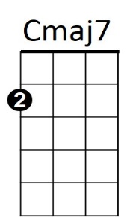



D

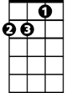

Am

B7

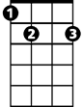

**It's Raining Men (Paul Jabara / Paul Shaffer / Bob Esty)**

**Intro: Dm F Bb A**

**Dm**

Humidity is rising - Barometer's getting low

According to our sources,



Bb



Dm

F

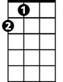

A



A7

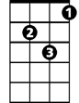

Gm

**A7**

The street's the place to go

**Dm**

Cause tonight for the first time

**Gm**

Just about half-past ten

**A**

For the first time in history

**A7**

It's gonna start raining men.

**Bb C**

It's Raining Men! Hallelujah! –

**A Dm**

It's Raining Men! Amen!

**Gm**

I'm gonna go out to run and let myself get

**A A7**

Absolutely soaking wet!

**Bb C**

It's Raining Men! Hallelujah! –

**A Dm Am Dm**

It's Raining Men! Every Spe – ci - men!

**Gm**

Tall, blonde, dark and lean

**A A7**

Rough and tough and strong and mean



C

**Bbmaj7 C**

God bless Mother Nature,

**A7 Dm**

She's a single woman too

**Bbmaj7 C**

She took from the heavens

**A7 Dm**

And she did what she had to do

**Bbmaj7 C A7 Dm**

She taught every angel to rearrange the sky

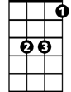

Bb



A

**Bb**

So that each and every woman

**A7**

Could find her perfect guy

**Bb C**

It's Raining Men! Hallelujah! –

**A Dm**

It's Raining Men! Amen!

**Bb C**

It's Raining Men! Hallelujah! –

**A Dm C A7**

It's Raining Men! A-me – e - en!

**Dm F Bb**

I - feel storm - y weather moving in

**A**

About to begin, about to begin

**Dm**

Hear the thun-der

**F Bb**

Don't you lose your HEAD!

**A**

Rip off the roof and stay in bed

**Bbmaj7 C**

God bless Mother Nature,

**A7 Dm**

She's a single woman too

**Bbmaj7 C**

She took from the heavens

**A7 Dm**

And she did what she had to do

**Bbmaj7 C A7 Dm**

She taught every angel to rearrange the sky

**Bb**

So that each and every woman

**A7**

Could find her perfect guy

**BARITONE**



Dm



F

**(First Verse)**

**(2X)**

**Bb C**

It's Raining Men! Hallelujah!

**A Dm**

It's Raining Men! Amen!

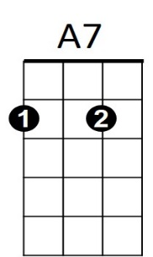

C

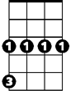

Gm