It's The Most Wonderful Time of the Year (Edward Pola and George Wyle, 1963) (C)
It's The Most Wonderful Time of the Year by Andy Williams (1963) - Version 2

Intro: C Am Dm G↓  C Am Dm G C Am Dm G Dm G  1. It's the most wonderful time of the year, with the kids jingle belling  C F  And everyone telling you, “Be of good cheer”  C Am Dm G C Am Dm G  It's the most wonderful time of the year  C Am Dm G C Am Dm G Dm G  2. It's the hap-happiest sea-son of all, with those holiday greetings  C F  And gay happy meetings when friends come to call  C Am Dm G C7  It's the hap-happiest sea-son of all  Bridge  F C Am  There'll be parties for hosting, marsh-mallows for toasting,  Dm G C C7 Fm  And caroling out in the snow. There'll be scary ghost stories  Eb Fm G G7  And tales of the glories of Christmases long, long ago.  C Am Dm G C Am Dm G  3. It's the most wonderful time of the year.  Dm G C  There'll be much mistle-toeing, and hearts will be glowing,  F  When love ones are near. [2nd time through go to Outro]  C Am Dm G C C7  It's the most wonderful time of the year.  Repeat from Bridge – except last line of Verse 3  Outro:  C Am Dm C Am Dm  It's the most wonderful time, yes, the most wonderful time,  C Am Dm G C G Fm C  Oh, the most wonderful time of the year. |  |  |  |  |  |  | 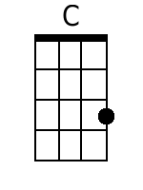  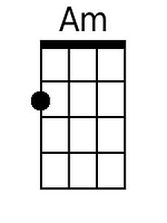
 |  |  |  |  |  |  | 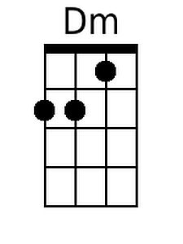 | 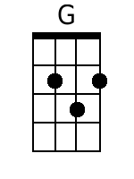
 |  |  |  |  |  |  | 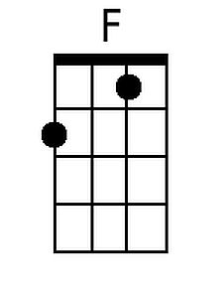
 |  |  |  |  |  |  | 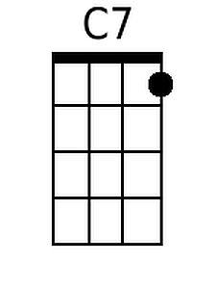 | 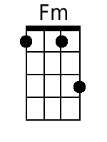
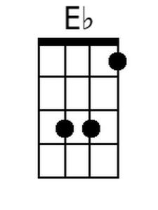
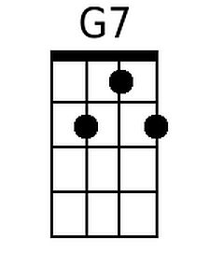
Baritone
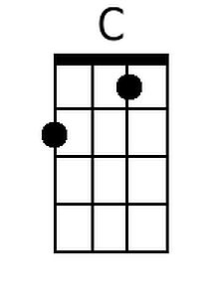 | 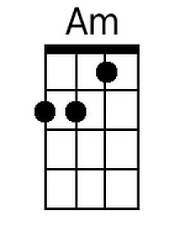 | 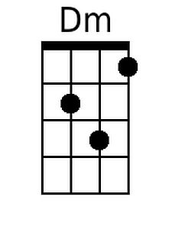 | 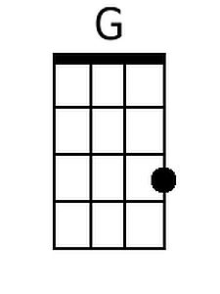 | 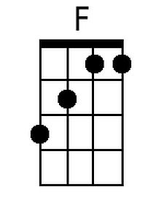 | 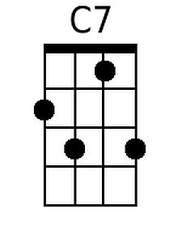 | 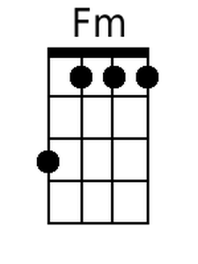 | 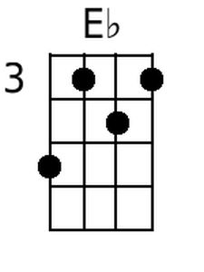 | 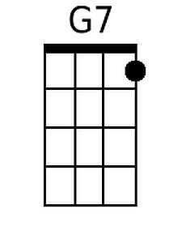

It's The Most Wonderful Time of the Year (Edward Pola and George Wyle, 1963) (G)
It's The Most Wonderful Time of the Year by Andy Williams (1963) - Version 2

Intro: G Em Am D↓  G Em Am D G Em Am D Am D  1. It's the most wonderful time of the year, with the kids jingle belling  G C  And everyone telling you, "Be of good cheer"  G Em Am D G Em Am D  It's the most wonderful time of the year.  G Em Am D G Em Am D Am D  2. It's the hap-happiest sea-son of all, with those holiday greetings  G C  And gay happy meetings when friends come to call  G Em Am D G7  It's the hap-happiest sea-son of all  Bridge  C G Em  There'll be parties for hosting, marsh-mallows for toasting,  Am D G G7 Cm  And caroling out in the snow. There'll be scary ghost stories  Bb Cm D D7  And tales of the glories of Christmases long, long ago.  G Em Am D G Em Am D  3. It's the most wonderful time of the year.  Am D G  There'll be much mistle-toeing, and hearts will be glowing,  C  When love ones are near. [2nd time through go to Outro]  G Em Am D G G7  It's the most wonderful time of the year.  Repeat from Bridge – except last line of Verse 3  Outro:  G Em Am G Em Am  It's the most wonderful time, yes, the most wonderful time,  G Em Am D G D Cm G  Oh, the most wonderful time of the year. |  |  |  |  |  |  |  | 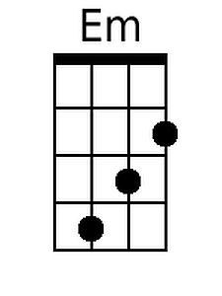
 |  |  |  |  |  |  |  | 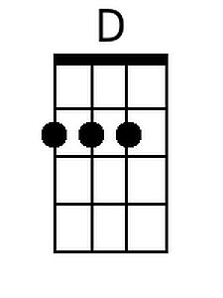
 |  |  |  |  |  |  | 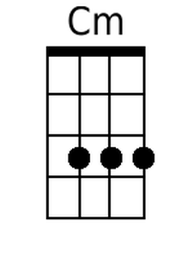 | 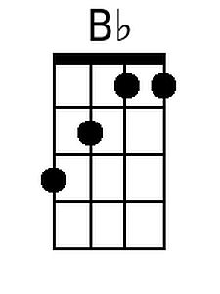
 |  |  |  |  |  |  | 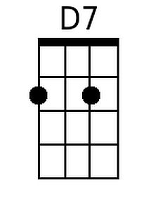
Baritone
 | 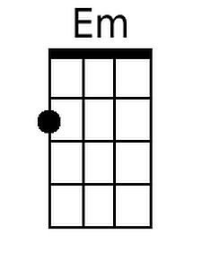 |  | 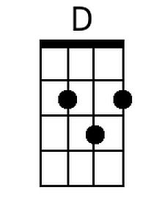 |  |  | 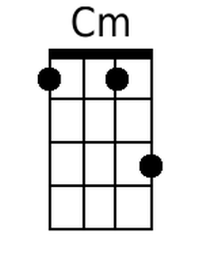 | 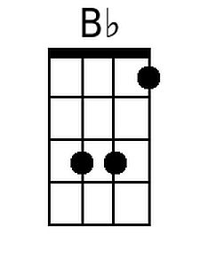 | 