**It's the Most Wonderful Time of the Year (Eddie Pola / George Wyle) Key C**

**C Am Dm G C (hold 4 beats)**

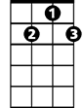

G7

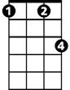

Fm

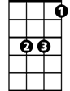

Eb

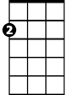

Am



G

F

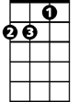

Dm



C

It's the most wonderful time of the year

**Dm G**

With the kids jingle bell-ing

**C Am F**

And everyone telling you "Be of good cheer" -

**C Am Dm G C**

It's the most wonderful time of the year

**C Am Dm G C (hold 4 beats)**

It's the hap-happiest sea - son of all

**Dm G**

With those holiday greetings

**C Am F**

And gay happy meetings when friends come to call -

**C Am Dm G C**

It's the hap-happiest sea-son of all

**Chorus:**

**Fm C Am**

There'll be parties for hosting, marshmallows for toasting

**Dm G C**

**BARITONE**

C

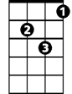

Dm



F



G



Am

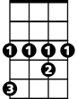

Eb

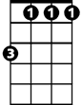

Fm

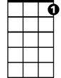

G7

And caroling out in the snow

**Fm Eb**

There'll be scary ghost stories, and tales of the glories

**Fm G G7**

Of Christmases long, long ago

**C Am Dm G C (hold 4 beats)**

It's the most wonderful time of the year

**Dm G**

There'll be much mistletoe-ing

**C Am F**

And hearts will be glowing when loved ones are near -

**C Am Dm G C**

It's the most wonderful time of the year

**(Chorus)**

**C Am Dm G C (hold 4 beats)**

It's the most wonderful time of the year

**Dm G**

There'll be much mistletoe-ing

**C Am F**

And hearts will be glowing when loved ones are near

**C Am Dm C Am Dm**

It's the most wonderful time - Yes, it's the most wonderful time -

**C Am Dm G C**

It's the most wonderful time ------ of the year

**It's the Most Wonderful Time of the Year (Eddie Pola / George Wyle) Key G**

**G Em Am D G (hold 4 beats)**

It's the most wonderful time of the year

Em

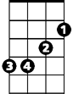

G



Am

**BARITONE**

**Am D**

With the kids jingle bell-ing

**G Em C**

And everyone telling you "Be of good cheer" -

**G Em Am D G**

It's the most wonderful time of the year



C

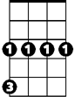

Cm

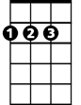

D

**G Em Am D G (hold 4 beats)**

It's the hap-happiest sea - son of all

**Am D**

With those holiday greetings

**G Em C**

And gay happy meetings when friends come to call -



Bb

**G Em Am D G**

It's the hap-happiest sea-son of all

**Chorus:**

**Cm G Em**

There'll be parties for hosting, marshmallows for toasting

**Am D G**

And caroling out in the snow

**Cm Bb**



Em



G



Am

There'll be scary ghost stories, and tales of the glories

**Cm D D7**

Of Christmases long, long ago

**G Em Am D G (hold 4 beats)**

It's the most wonderful time of the year



D

C



**Am D**



Cm

There'll be much mistletoe-ing

**G Em C**

And hearts will be glowing when loved ones are near -

**G Em Am D G**

It's the most wonderful time of the year



Bb

**(Chorus)**

**G Em Am D G (hold 4 beats)**

It's the most wonderful time of the year

**Am D**

There'll be much mistletoe-ing

**G Em C**

And hearts will be glowing when loved ones are near -

**G Em Am G Em Am**

It's the most wonderful time - Yes, it's the most wonderful time -

**G Em Am D G**

It's the most wonderful time ------ of the year