**Itsy Bitsy Teenie Weenie (Brian Hyland)**

**Intro:**

**C F G7**

Bop bop bop bop babopbop bop bop bop

**C Dm G7**

She was afraid to come out of the locker

**Dm G7 C**

She was as nervous as she could be

**C C7 F**

She was afraid to come out of the locker

**C Dm G7 C**

She was afraid that somebo - dy would see

**Chorus:**

**Tacet**

Two, three, four, tell the people what she wore!

**G7 C**

It was an itsy bitsy teenie weenie yellow polka-dot bikini

**G7 C**

That she wore for the first time today.

**G7 C**

An itsy bitsy teenie weenie yellow polka-dot bikini

**G7 C**

So in the locker she wanted to stay.

**Tacet**

Two, three, four, stick around we'll tell you more!

**(Intro)**

**C Dm G7**

She was afraid to come out in the open

**Dm G7 C**

And so a blanket around her she wore.

**C C7 F**

She was afraid to come out in the open.

**C Dm G7 C**

And so she sat bundled up on the shore.

**(Chorus)**

**G7 C**

So in the blanket she wanted to stay.

**Tacet**

Two, three, four, stick around we'll tell you more!

**(Intro)**

**C Dm G7**

Now she is afraid to come out of the water.

**Dm G7 C**

And I wonder what she's gonna do.

**C C7 F**

'Cause she's afraid to come out of the water.

**C Dm G7 C**

And now the poor little girl's turning blue.

**(Chorus)**

**G7 C**

So in the water she wanted to stay.

**G7**

From the locker to the blanket,

**C**

From the blanket to the shore,

**G7**

From the shore to the water

**C**

Guess there isn't any more. – cha cha cha!

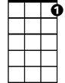

C7

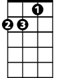

Dm



C

F

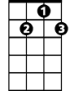

G7

**BARITONE**

C

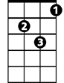

Dm

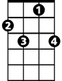

C7



F



G7