Jamaica Farewell
Lord Burgess (Irving Burgie) & Trad. Jamaican folk song, ca. 1957
Jamaica Farewell (C)
(Lord Burgess [Irving Burgie] & Trad. Jamaican folk song, ca. 1957)
Jamaica Farewell by Harry Belefonte (1957)

Intro (Last two lines of Chorus)  C F  Down the way where the nights are gay,  G F C  And the sun shines brightly on the mountain top,  C F  I took a trip on a sailing ship,  G F C  And when I reached Jamaica I made a stop.  Chorus  C F  But, I’m sad to say, I’m on my way,  G C  Won’t be back for many a day.  C F  My heart is down, my head is turning around,  G F C  I had to leave a little girl in Kingston town.  C F  Sounds of laughter everywhere,  G F C  And the dancers swinging to and fro,  C F  I must declare that my heart is there,  G F C  Though I’ve been from Maine to Mexico. Chorus  C F  Down at the market you can hear,  G F C  Ladies cry out while on their heads they bear,  C F  Ackie rice, salt fish are nice,  G F C  And the rum is fine any time of year. Chorus | 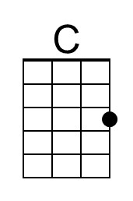
 | 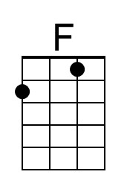
 | 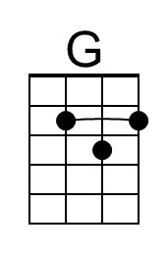
 | 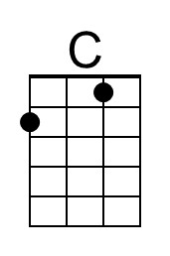
 | 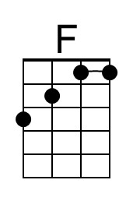
 | 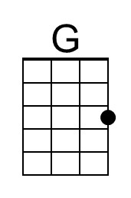

Jamaica Farewell (G)
(Lord Burgess [Irving Burgie] & Trad. Jamaican folk song, ca. 1957)
Jamaica Farewell by Harry Belefonte (1957)

Intro (Last two lines of Chorus)

G C
Down the way where the nights are gay,
D C G
And the sun shines brightly on the mountain top,
G C
I took a trip on a sailing ship,
D C G
And when I reached Jamaica I made a stop.

Chorus
G C
But, I’m sad to say, I’m on my way,
D G
Won’t be back for many a day.
G C
My heart is down, my head is turning around,
D C G
I had to leave a little girl in Kingston town.

G C
Sounds of laughter everywhere,
D C G
And the dancers swinging to and fro,
G C
I must declare that my heart is there,
D C G
Though I’ve been from Maine to Mexico. Chorus

G C
Down at the market you can hear,
D C G
Ladies cry out while on their heads they bear,
G C
Ackie rice, salt fish are nice,
D C G
And the rum is fine any time of year. Chorus
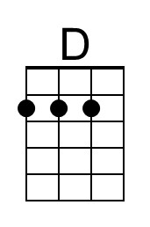
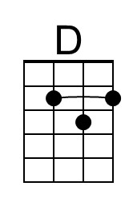

Jamaica Farewell (F)
(Lord Burgess [Irving Burgie] & Trad. Jamaican folk song, ca. 1957)
Jamaica Farewell by Harry Belefonte (1957)

Intro (Last two lines of Chorus)

F B♭
Down the way where the nights are gay,
C B♭ F
And the sun shines brightly on the mountain top,
F B♭
I took a trip on a sailing ship,
C B♭ F
And when I reached Jamaica I made a stop.

Chorus
F B♭
But, I’m sad to say, I’m on my way,
C F
Won’t be back for many a day.
F B♭
My heart is down, my head is turning around,
C B♭ F
I had to leave a little girl in Kingston town.

F B♭
Sounds of laughter everywhere,
C B♭ F
And the dancers swinging to and fro,
F B♭
I must declare that my heart is there,
C B♭ F
Though I’ve been from Maine to Mexico. Chorus

F B♭
Down at the market you can hear,
C B♭ F
Ladies cry out while on their heads they bear,
F B♭
Ackie rice, salt fish are nice,
C B♭ F
And the rum is fine any time of year. Chorus
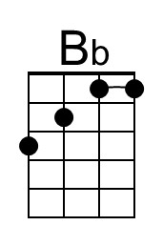
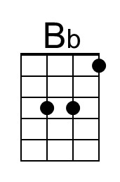

Jamaica Farewell (C)
(Lord Burgess [Irving Burgie] & Trad. Jamaican folk song, ca. 1957)
Jamaica Farewell by Harry Belefonte (1957)

Intro (Last two lines of Chorus)

C F
Down the way where the nights are gay,
G F C
And the sun shines brightly on the mountain top,
C F
I took a trip on a sailing ship,
G F C
And when I reached Jamaica I made a stop.

Chorus
C F
But, I’m sad to say, I’m on my way,
G C
Won’t be back for many a day.
C F
My heart is down, my head is turning around,
G F C
I had to leave a little girl in Kingston town.

C F
Sounds of laughter everywhere,
G F C
And the dancers swinging to and fro,
C F
I must declare that my heart is there,
G F C
Though I’ve been from Maine to Mexico. Chorus

C F
Down at the market you can hear,
G F C
Ladies cry out while on their heads they bear,
C F
Ackie rice, salt fish are nice,
G F C
And the rum is fine any time of year. Chorus

This page is intentionally blank.

