Jambalaya (On The Bayou) (Hank Williams, 1952)
GCEA

1 5(7)  Goodbye, Joe, me gotta go, me oh my oh.  1  Me gotta go, pole the pirogue down the bayou.  5(7)  My Yvonne, the sweetest one, me oh my oh.  1  Son of a gun, we'll have big fun on the bayou.  Chorus:  5(7)  Well jambalaya and a crawfish pie and filé gumbo  1  Cause tonight I'm gonna see my ma cher amio.  5(7)  Pick guitar, fill fruit jar and be gayo,  1  Son of a gun, we'll have big fun on the bayou.  1 5(7)  Thibodaux, Fontaineaux, the place is buzzin',  1  Kinfolk come to see Yvonne by the dozen.  5(7)  We dress in style and go hog wild, me oh my oh.  1  Son of a gun, we'll have big fun on the bayou.  (Chorus) (2X) | 1 | 5(7)
 | 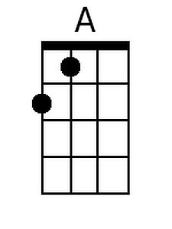 | 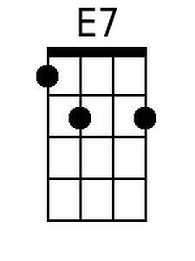
 | 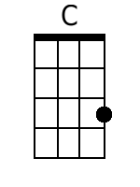 | 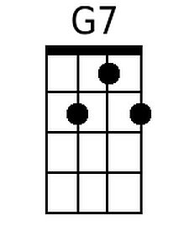
 | 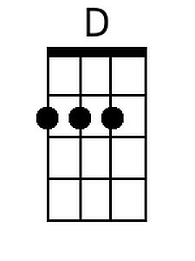 | 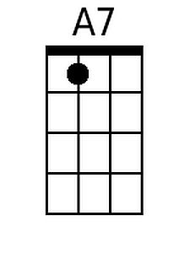
 | 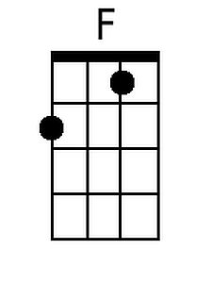 | 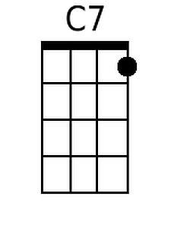
 | 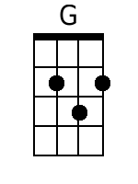 | 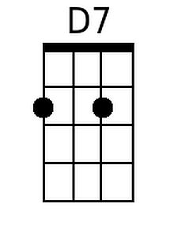

Jambalaya (On The Bayou) (Hank Williams, 1952)
DGBE

1 5(7)  Goodbye, Joe, me gotta go, me oh my oh.  1  Me gotta go, pole the pirogue down the bayou.  5(7)  My Yvonne, the sweetest one, me oh my oh.  1  Son of a gun, we'll have big fun on the bayou.  Chorus:  5(7)  Well jambalaya and a crawfish pie and filé gumbo  1  Cause tonight I'm gonna see my ma cher amio.  5(7)  Pick guitar, fill fruit jar and be gayo,  1  Son of a gun, we'll have big fun on the bayou.  1 5(7)  Thibodaux, Fontaineaux, the place is buzzin',  1  Kinfolk come to see Yvonne by the dozen.  5(7)  We dress in style and go hog wild, me oh my oh.  1  Son of a gun, we'll have big fun on the bayou.  (Chorus) (2X) | 1 | 5(7)
 | 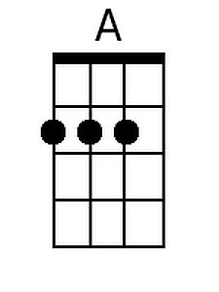 | 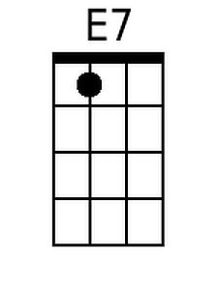
 | 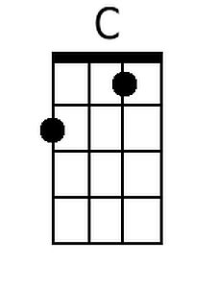 | 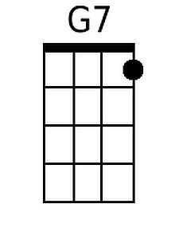
 | 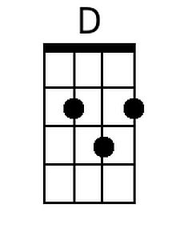 | 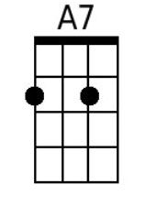
 | 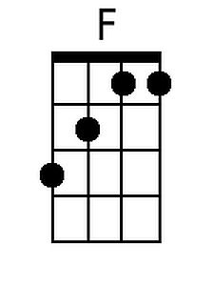 | 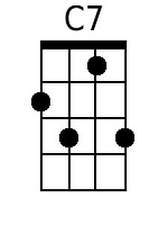
 | 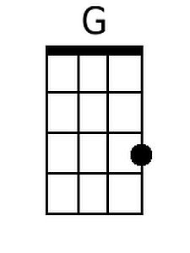 | 