Jawaiian Country Roads
Medley of Take Me Home Country Road by Israel Kamakawiwo'ole (Hawaiian)
and Take Me Home, Country Roads by Toots & Maytals (Jamaican)
2/2 Time – Tempo 88 BPM (Double Time 175 BPM)
Reggae Beat
Intro (4 Measures) G  G Em  __ Almost heaven, __ West Ma-ka’-ha.  D7 C G  __ High-ridge Mountains, crystal clear blue water.  G Em  __ All my friends there, hanging on the beach.  D7 C G  Young and old among them, feel the ocean breeze.  Chorus 1  G D7 Em C  Country road, take me home, to the place, I be-long,  G D7 C G  West Ma-ka-ha, Mount Ka’-ala. Take me home, oh country road.  Bridge  Em D G  __ I heard a voice, in the morning calm she calls me,  C G D  As though to re-mind me of my home far a-way.  Em F C  Driving down the road I feel the Spirit coming to me,  D D7 | D7  From yesterday, yester-day.  G Em  __ All my memories hold heaven on high;  D7 C G  Brown skinned woman, clear blue island sky,  G Em  __ Daytime sunshine, ooo-oh so bright.  D7 C G  Midnight moon a-glowing, stars up in the sky. Chorus 1 |  |  |  |  |  |  | 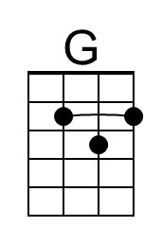
 |  |  |  |  |  |  | 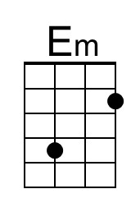
 |  |  |  |  |  |  | 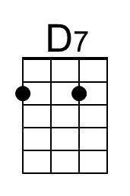
 |  |  |  |  |  |  | 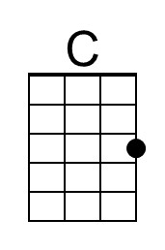
 |  |  |  |  |  |  | 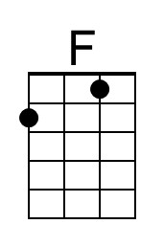
 |  |  |  |  |  |  | 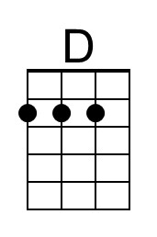
Bari | 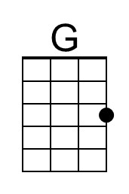 | 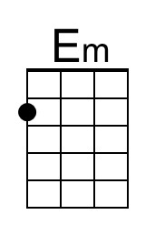 | 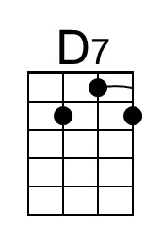 | 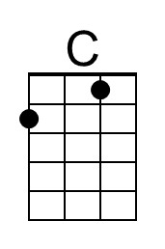 | 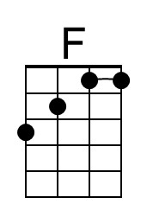 | 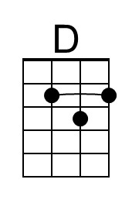

Jawaiian Country Roads – Page 2

G Em
__ Almost heaven, __ West Jamaica,
D7 C G
__ True ridge mountains, shining down the river.
G Em
__ All my friends there, older than those ridge,
D7 C G
Younger than the mountains, blowin’ like a breeze.

Chorus 2
G D7 Em C
Country road, take me home to the place, I be-long,
G D7 C G
West Ja-maica, my ol' momma. Take me home, oh country road.

Bridge
Em D G
__ I heard a voice, in the morning calm she calls me,
C G D
As though to re-mind me of my home far a-way.
Em F C
Driving down the road I feel the Spirit coming to me,
D D7 | D7
From yesterday, yester-day.

G Em
__ All my memories, all gathered 'round her,
D7 C G
__ My my lady swingin' through the water (water). [Echo optional]
G Em
__ Dark and dusty, painted on the sky,
D7 C G
Misty taste of moonshine, tears gone from my eyes. Chorus 2

Chorus 1
G D7 Em C
Country road, take me home, to the place, I be-long,
G D7 C G
West Ma-ka-ha, Mount Ka’-ala. Take me home, oh country road.

Outro
D7 G D7 C G
Take me home, country roads, take me home, country ro - ads.

