**Jingle Bell Rock (Bobby Helms)**

C 25

**Intro (Five Measures): F - Fm - F - G - C**

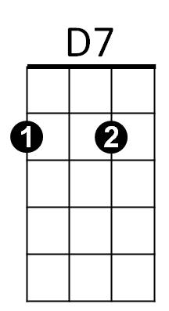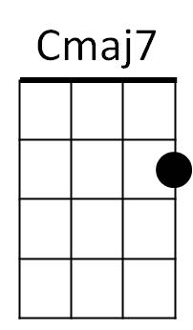

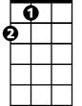

A



G

F

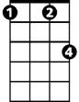

Fm



C

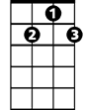

G7

**C Cmaj7 C Cmaj7**

Jingle bell, jingle bell, jingle bell rock,

**C Cmaj7 F G7**

Jingle bells swing and jingle bells ring,

**G G7 G G7**

Snowing and blowing up bushels of fun,

**D7 G7**

Now the jingle hop has begun.

**C Cmaj7 C Cmaj7**

Jingle bell, jingle bell, jingle bell rock,

**C Cmaj7 F G7**

Jingle bells chime in jingle bell time,

**G G7 G G7 D7 G7 C C7**

Dancing and prancing in Jingle Bell Square in the frosty air.

**F Fm C C7**

What a bright time, it's the right time to rock the night away,

**D D7 G G7 G G7**

Jingle bell time is a swell time - - - to go riding in a one-horse sleigh.

**Reprise:**

**C Cmaj7 C Cmaj7 C Cmaj7 A**

Giddy-up jingle horse, pick up your feet, jingle around the clock,

**F Fm F G C G7**

Mix and a-mingle in the jingling beat, that's the jingle bell rock.

**(Repeat verses 1 & 2; No Reprise)**

**C Cmaj7 C Cmaj7 C Cmaj7 A**

Giddy-up jingle horse, pick up your feet, jingle around the clock,

**F Fm F G**

Mix and a-mingle in the jingling beat, that's the jingle bell,

**F G F G C C G7 C**

That’s the jingle bell, that's the jingle bell rock.

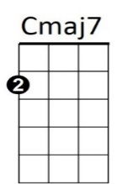

**BARITONE**



D7

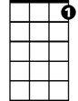

G7

C



G

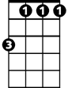

Fm



F

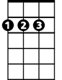

A