**Jingle Bells (James Pierpont, 1857)**

C10 C

**C F**

Dashing through the snow, in a one-horse open sleigh,

**G7 C**



C

F



O'er the fields we go, laughing all the way,

**F**

Bells on bobtails ring, making spirits bright,

**G7 C**

What fun it is to ride and sing a sleighing song tonight.

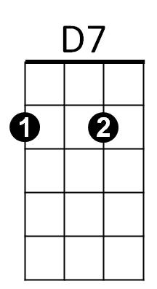

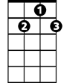

G7

**Chorus:**

**G C**

Oh! Jingle bells, jingle bells, jingle all the way,

**F C D7 G7**

Oh what fun it is to ride in a one-horse open sleigh.

**C**

Hey! Jingle bells, jingle bells, jingle all the way,

**F C G7 C**

Oh what fun it is to ride in a one-horse open sleigh.

**C F**

A day or two ago, I thought I'd take a ride,

**G7 C**

And soon Miss Fanny Bright was seated by my side;

**F**

The horse was lean and lank, misfortune seemed his lot;

**G7 C**

He got into a drifted bank and then we got upsot.

**BARITONE**

**(CHORUS)**

C

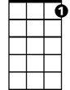

G7



F



D7

**Jingle Bells (James Pierpont, 1857)**

C10 F

**F Bb**

F



Dashing through the snow, in a one-horse open sleigh,

**C7 F**

O'er the fields we go, laughing all the way,

**Bb**

Bells on bobtails ring, making spirits bright,

**C7 F**



Bb

What fun it is to ride and sing a sleighing song tonight.

**Chorus:**

**C7 F**



C7

Oh! Jingle bells, jingle bells, jingle all the way,

**Bb F G7 C7**

Oh what fun it is to ride in a one-horse open sleigh.

**F**

Hey! Jingle bells, jingle bells, jingle all the way,

**Bb F C7 F**



G7

Oh what fun it is to ride in a one-horse open sleigh.

**F Bb**

A day or two ago, I thought I'd take a ride,

**C7 F**

And soon Miss Fanny Bright was seated by my side;

**Bb**

The horse was lean and lank, misfortune seemed his lot;

**C7 F**

He got into a drifted bank and then we got upsot.

**BARITONE**

**(CHORUS)**

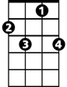

C7



G7

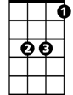

Bb



F

**Jingle Bells (James Pierpont, 1857)**

C10 G

**G C**

Dashing through the snow, in a one-horse open sleigh,



G

**D7 G**

O'er the fields we go, laughing all the way,

**C**

Bells on bobtails ring, making spirits bright,

**D7 G**



C

What fun it is to ride and sing a sleighing song tonight.

**Chorus:**

**D7 G**

Oh! Jingle bells, jingle bells, jingle all the way,

**C G A7 D7**

Oh what fun it is to ride in a one-horse open sleigh.

**G**

Hey! Jingle bells, jingle bells, jingle all the way,

**C G D7 G**

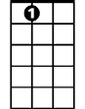

A7

Oh what fun it is to ride in a one-horse open sleigh.

**G C**

A day or two ago, I thought I'd take a ride,

**D7 G**

And soon Miss Fanny Bright was seated by my side;

**C**

The horse was lean and lank, misfortune seemed his lot;

**D7 G**

He got into a drifted bank and then we got upsot.

**BARITONE**

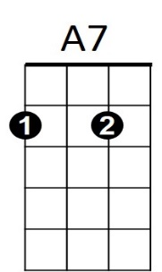**(CHORUS)**



D7

C



G