
Jingle Bells (One Horse Open Sleigh)
C89b C
(James Lord Pierpont, 1857) – The Revenge Version of "Jingle Bells"
With thanks to Deb Fitzloff

Intro (last 2 lines of verse)  Dm C G7 C G7  C  1. Dashing thro' the snow,  C7 F  In a one horse open sleigh,  Dm G7 C  O'er the hills we go, laughing all the way;  (C)  Bells on bob tail ring,  C7 F  making spirits bright,  Dm C  Oh what sport to ride and sing  G7 C  A sleighing song to night.  Chorus  G7 C  Oh, Jingle bells, Jingle bells,  - C7  Jingle all the way.  F C  Oh! what joy it is to ride  D7 G - G7  In a one horse open sleigh.  C  Jingle bells, Jingle bells,  - C7  Jingle all the way.  F C  Oh! what joy it is to ride  G7 C - G7  In a one horse open sleigh. | C C7 F  2. A day or two ago, I tho't I'd take a ride,  Dm G7 C  And soon Miss Fannie Bright, Was seated by my side.  (C)  The horse was lean and lank,  C7 F  Mis-fortune seem'd his lot,  Dm C G7 C  He got into a drifted bank and we? We got up-sot.  Chorus  C C7 F  3. A day or two ago, the story I must tell,  Dm G7 C  I went out on the snow and on my back I fell;  (C) C7 F  A gent was riding by, in a one horse open sleigh,  Dm C  He laughed as there I sprawling lie,  G7 C  But quickly drove a-way. Chorus  C  4. Now the winter’s past.  C7 F  The snow’s turned earth to mud  Dm G7  That gent who'd laughed at me  C  slipped in it with a THUD!  (C) C7 F  I chanced to ride on by, upon my bob tailed bay  Dm C  I stopped and took a pic to post,  G7 C  Then quickly rode a-way. Chorus
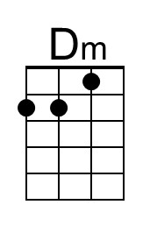 | 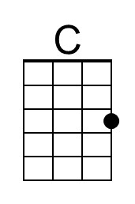 | 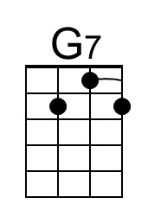 | 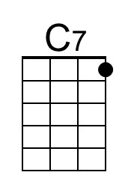 | 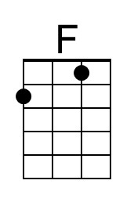 | 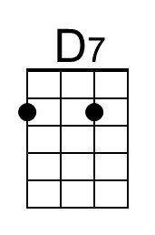 | 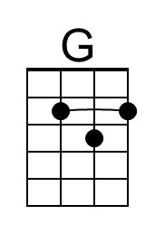
Baritone | 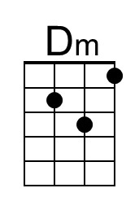 | 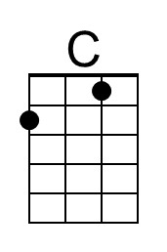 | 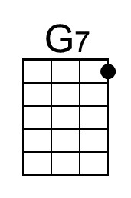 | 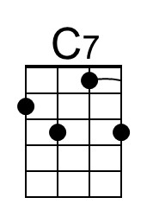 | 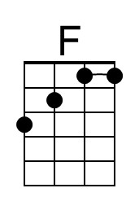 | 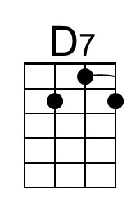 | 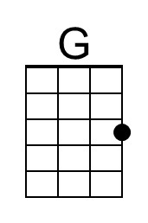
Jingle Bells (One Horse Open Sleigh)
C89b G
(James Lord Pierpont, 1857) – The Revenge Version of "Jingle Bells"
With thanks to Deb Fitzloff

Intro (last 2 lines of verse)  Am G D7 G D7  G  1. Dashing thro' the snow,  G7 C  In a one horse open sleigh,  Am D7 G  O'er the hills we go, laughing all the way;  (G) G7 C  Bells on bob tail ring, making spirits bright,  Am G  Oh what sport to ride and sing  D7 G  A sleighing song to night.  Chorus  D7 G  Oh, Jingle bells, Jingle bells,  - G7  Jingle all the way.  C G  Oh! what joy it is to ride  A7 D - D7  In a one horse open sleigh.  G  Jingle bells, Jingle bells,  - G7  Jingle all the way.  C G  Oh! what joy it is to ride  D7 G - D7  In a one horse open sleigh. | G G7 C  2. A day or two ago, I tho't I'd take a ride,  Am D7 G  And soon Miss Fannie Bright, Was seated by my side.  (C)  The horse was lean and lank,  G7 C  Mis-fortune seem'd his lot,  Am G D7 G  He got into a drifted bank and we? We got up-sot.  Chorus  G G7 C  3. A day or two ago, the story I must tell,  Am D7 G  I went out on the snow and on my back I fell;  (C) G7 C  A gent was riding by, in a one horse open sleigh,  Am G  He laughed as there I sprawling lie,  D7 G  But quickly drove a-way. Chorus  G  4. Now the winter’s past.  G7 C  The snow’s turned earth to mud  Am D7  That gent who'd laughed at me  G  Slipped in it with a THUD!  (C) G7 C  I chanced to ride on by, u-pon my bob-tailed bay  Am G  I stopped and took a pic to post,  D7 G  Then quickly rode a-way. Chorus
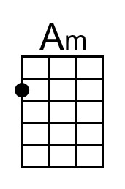 |  |  |  |  | 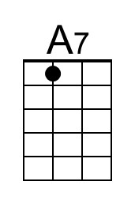 | 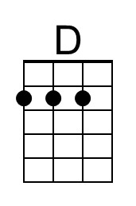
Baritone | 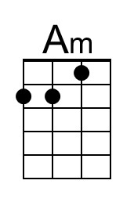 |  |  |  |  | 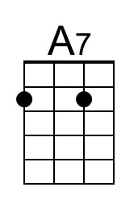 | 