Johnny B. Goode
Chuck Berry – At YouTube, Johnny B. Goode

"Johnny B. Goode" is a 1958 rock-and-roll song written and first recorded by Chuck Berry in a 12-bar blues style ( I I I I IV IV I I V V I I ). The song was a major hit, peaking at number two on Billboard magazine's Hot R&B Sides chart and number eight on its Hot 100 chart.
“Johnny B. Goode" is considered one of the most recognizable songs in the history of popular music. Credited as "the first rock & roll hit about rock & roll stardom", it has been recorded by many other artists and has received several honors and accolades. The song is also ranked seventh on Rolling Stone's list of the "500 Greatest Songs of All Time".
Written by Berry in 1955, the song is about an illiterate "country boy" from the New Orleans area, who plays a guitar "just like ringing a bell", and who might one day have his "name in lights". Berry acknowledged that the song is partly autobiographical and that the original lyrics referred to Johnny as a "colored boy", but he changed it to "country boy" to ensure radio play. As well as suggesting that the guitar player is good, the title hints at autobiographic elements, because Berry was born at 2520 Goode Avenue, in St. Louis. The song was initially inspired by Johnnie Johnson, the regular piano player in Berry's band, but developed into a song mainly about Berry himself. Johnson played on many other recordings by Berry, but Lafayette Leake played the piano on this song.
The opening guitar riff of "Johnny B. Goode" is essentially a note-for-note copy of the opening single-note solo on Louis Jordan's "Ain't That Just Like a Woman" (1946), played by guitarist Carl Hogan.
When Chuck Berry was inducted during the first Rock and Roll Hall of Fame induction ceremony on January 23, 1986, he performed "Johnny B. Goode" and "Rock and Roll Music", backed by Bruce Springsteen and the E Street Band. The Hall of Fame included these songs and "Maybellene" in their list of the 500 songs that shaped rock and roll. It was inducted into the Grammy Hall of Fame in 1999, for its influence as a rock and roll single.
The Beatles recorded a version of the song on January 7, 1964, at the Playhouse Theatre in London for the BBC radio show Saturday Club. The Beatles' version featured John Lennon on vocals and rhythm guitar, Paul McCartney on bass guitar, George Harrison on lead guitar, and Ringo Starr on drums. Chuck Berry was a favorite of the band members. They previously and subsequently recorded versions of other songs by Berry, including "Roll Over Beethoven", released on the album “With the Beatles” in 1963, and "Rock and Roll Music", released on “Beatles for Sale” in 1964, along with several others that subsequently were released on Live at the BBC. A version with altered lyrics was recorded in 1964 and can be heard at YouTube, Johnny B. Goode - The Beatles.
Chuck Berry died at his home in St. Charles County, Missouri, near the town of Wentzville, at the age of 90 on March 18, 2017.
Source: Wikipedia, “Johnny B. Goode,” https://en.wikipedia.org/wiki/Johnny_B._Goode , & others.
Johnny B. Goode
Chuck Berry (1958) At YouTube, Johnny B. Goode

GCEA  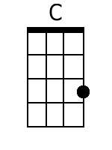  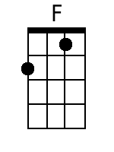  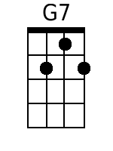 | Intro: C C F C G7 C G7 [Chorus]  C  1. Deep down in Louisiana close to New Orleans  C  Way back up in the woods among the evergreens  F  There stood a log cabin made of earth and wood  C  Where lived a country boy named Johnny B. Goode  G7  Who never ever learned to read or write so well,  C  But he could play the guitar just like a ringin’ a bell.  Chorus  C  Go go, go Johnny go. Go, go Johnny go.  F C  Go, go Johnny go. Go, go Johnny go.  G7 C G7  Go, Johnny B. Goode…  C  2. He used to carry his guitar in a gunny sack  C  And go sit beneath a tree by the railroad track.  F  Oh, engineers could see him sittin' in the shade  C  Strummin’ to the rhythm that the drivers made  G7  People passing by… they would stop and say  C  Oh my but that little country boy can play.  Chorus  C  3. His mother told him “someday you will be a man”  C  And you will be the leader of a big ole’ band  F  Many people comin' from miles around  C  To hear you play your music till the sun go down  G7  Maybe someday your name will be in lights  C  Sayin’ “Johnny B. Goode tonight”.  Chorus  C  Go go, go Johnny go. Go go, go Johnny go.  F C  Go go, go Johnny go. Go go, Johnny go.  G7 C C C C C [RING]  Go, Johnny B. Goode…  Strumming Pattern for last four chords:  DUD DUD DUD D [RING] | Bari  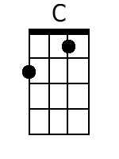  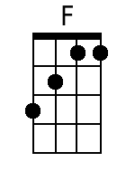  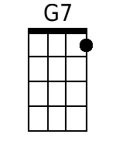

Johnny B. Goode
Chuck Berry (1958) At YouTube, Johnny B. Goode

GCEA  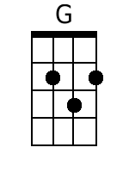  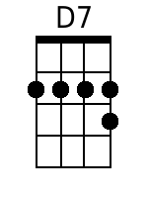 | Intro: G G C G D7 G D7 [Chorus]  G  1. Deep down in Louisiana close to New Orleans  G  Way back up in the woods among the evergreens  C  There stood a log cabin made of earth and wood  G  Where lived a country boy named Johnny B. Goode  D7  Who never ever learned to read or write so well,  G  But he could play the guitar just like a ringin’ a bell.  Chorus  G  Go go, go Johnny go. Go, go Johnny go.  C G  Go, go Johnny go. Go, go Johnny go.  D7 G D7  Go, Johnny B. Goode…  G  2. He used to carry his guitar in a gunny sack  G  And go sit beneath a tree by the railroad track.  C  Oh, engineers could see him sitting in the shade  G  Strummin’ to the rhythm that the drivers made  D7  People passing by… they would stop and say  G  Oh my but that little country boy can play.  Chorus  G  3. His mother told him “someday you will be a man”  G  And you will be the leader of a big ole’ band  C  Many people comin' from miles around  G  To hear you play your music till the sun go down  D7  Maybe someday your name will be in lights  G  Sayin’ “Johnny B. Goode tonight”.  Chorus  G  Go go, go Johnny go. Go go, go Johnny go.  C G  Go go, go Johnny go. Go go, Johnny go.  D7 G G G G G [RING]  Go, Johnny B. Goode…  Strumming Pattern for last four chords:  DUD DUD DUD D [RING] | Bari  