Jolene
Dolly Parton
Dolly Parton, Jolene (Capo on 3rd fret)

Chorus  Am C G Am  Jo-lene Jo-lene Jo-lene Jo-lene  G Em7 Am  I'm begging of you please don't take my man  Am C G Am  Jo-lene Jo-lene Jo-lene Jo-lene  G Em7 Am  Please don't take him just because you can  Am C  Your beauty is beyond compare  G Am  With flaming locks of auburn hair  G Em7 Am  With ivory skin and eyes of emerald green  Am C  Your smile is like a breath of spring  G Am  Your voice is soft like summer rain  G Em7 Am  And I cannot compete with Jo-lene  Am C  He talks about you in his sleep  G Am  And there's nothing I can do to keep  G Em7 Am  From crying when he calls your name Jo-lene  Am C  And I can easily understand  G Am  How you could easily take my man  G Em7 Am  But you don't know what he means to me Jo-lene. Chorus  Bari |  |  |  |  |  | 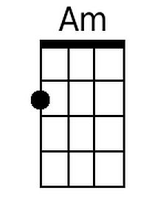  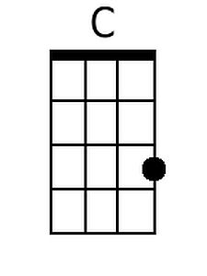  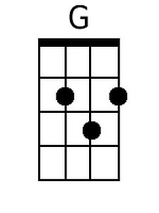  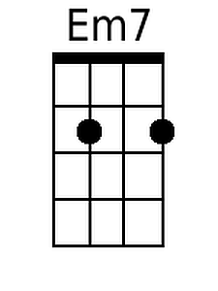
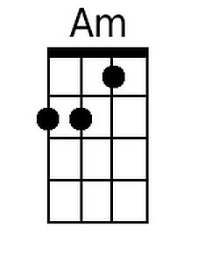 | 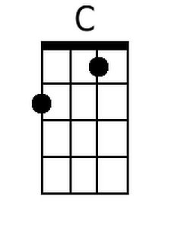 | 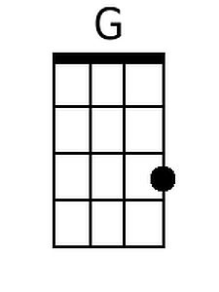 | 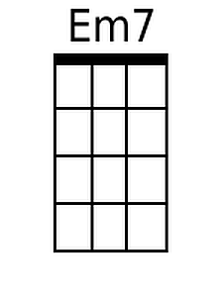

Am C
You can have your choice of men
G Am
But I could never love again
G Em7 Am
He's the only one for me Jo-lene
Am C
I had to have this talk with you
G Am
My happiness depends on you
G Em7 Am
And whatever you decide to do Jolene.

Outro:
Am
Jolene Jolene

