Jolly Old Saint Nicholas
C90 C
Words: "Lilly's Secret" by Emily Huntington Miller, The Little Corporal Magazine, December, 1865, alt. Music published by S. Brainard's Sons before 1881.

Intro: Last two lines of verse  C G7 Am Em  Jolly old St. Nicholas, Lean your ear this way!  F C G G7  Don't you tell a single soul, what I'm going to say  C G7 Am Em  Christmas Eve is coming soon; now, you dear old man,  F C G7 C - G7  Whisper what you'll bring to me, tell me if you can.  C G7 Am Em  When the clock is striking twelve, when I'm fast a-sleep,C  F C G G7  Down the chimney broad and black, with your pack you'll creep  C G7 Am Em  All the stockings you will find, hanging in a row;  F C G7 C - G7  Mine will be the shortest one, you'll be sure to know.  C G7 Am Em  Johnny wants a pair of skates, Suzy wants a dolly;  F C G G7  Nellie wants a story book; she thinks dolls are folly  C G7 Am Em  As for me, my little brain isn't very bright;  F C G7 C  Choose for me, old Santa Claus, what you think is right.  F C G7 C – G7 - C  Choose for me, old Santa Claus, what .. you .. think .. is .. right. |  |  |  |  |  |  |  | 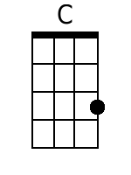
 |  |  |  |  |  |  |  | 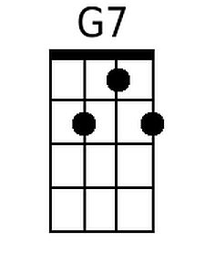
 |  |  |  |  |  |  |  | 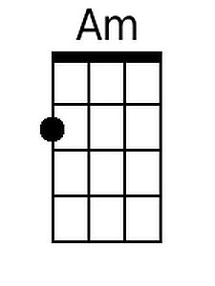
 |  |  |  |  |  |  |  | 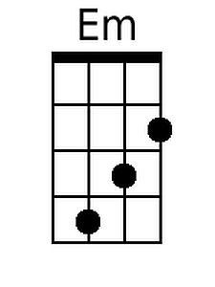
 |  |  |  |  |  |  |  | 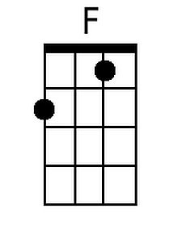
 |  |  |  |  |  |  |  | 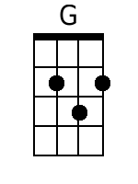
Baritone
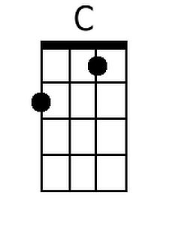 | 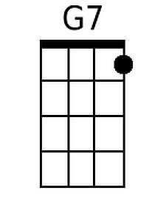 | 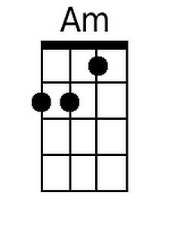 | 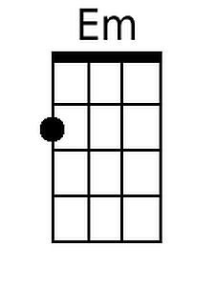 | 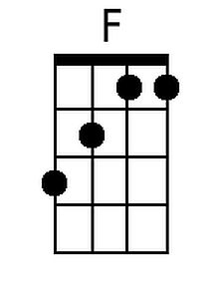 | 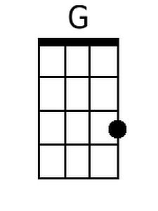

Jolly Old Saint Nicholas
C90 G
Words: "Lilly's Secret" by Emily Huntington Miller, The Little Corporal Magazine, December, 1865, alt. Music published by S. Brainard's Sons before 1881.

Intro: Last two lines of verse

G D7 Em Bm
Jolly old St. Nicholas, Lean your ear this way!
C G D D7
Don't you tell a single soul, what I'm going to say
G D7 Em Bm
Christmas Eve is coming soon; now, you dear old man,
C G D7 G - D7
Whisper what you'll bring to me, tell me if you can.

G D7 Em Bm
When the clock is striking twelve, when I'm fast a-sleep,
C G D D7
Down the chimney broad and black, with your pack you'll creep
G D7 Em Bm
All the stockings you will find, hanging in a row;
C G D7 G - D7
Mine will be the shortest one, you'll be sure to know.

G D7 Em Bm
Johnny wants a pair of skates, Suzy wants a dolly;
C G D D7
Nellie wants a story book; she thinks dolls are folly
G D7 Em Bm
As for me, my little brain isn't very bright;
C G D7 G
Choose for me, old Santa Claus, what you think is right.
C G D7 G - D7 - G
Choose for me, old Santa Claus, what .. you .. think .. is .. right.

 |  |  |  |  |  |  |  | 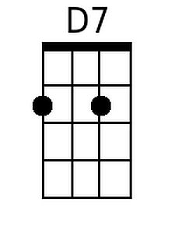
 |  |  |  |  |  |  |  | 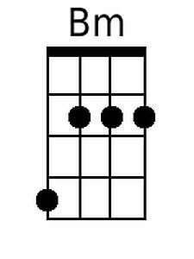
 |  |  |  |  |  |  |  | 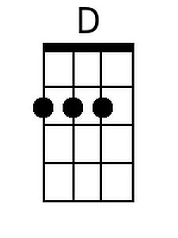
Baritone
 | 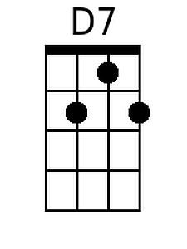 |  | 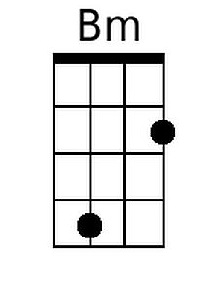 |  | 