Joseph Dearest, Joseph Mine
C118 C
Lyrics: Leipzig mystery play lullaby circa 1500, Josef, Lieber Josef Mein
Music: "Resonet in Laudibus", 14th Century German carol
Joseph Dearest, Joseph Mine by the Choir of the Second Church

Intro Last 2 lines of Verse  C F C  "Joseph dearest, Joseph mine,  C F C  Help me cradle the child di-vine;  Dm G7 Dm G  God re-ward thee and all that's thine  C Dm7 G C | C  In paradise." So prays the mother Mary.  Chorus  G Am F7  He came a-mong us at Christmas-tide,  Am F7 Dm7 G  At Christmas-tide, in Bethle-hem;  C G C  Men shall bring Him from far and wide  G C G C Em Am  Love's dia-dem: Je - sus, Je - sus,  F C F G7  Lo, He comes, and loves, and saves,  C | C  and frees us!  C F C  "Gladly, dear one, lady mine,  C F C  I will cradle this child of thine;  Dm G7 Dm G  God's own light on us both shall shine  C Dm7 G C | C  In paradise.” As prays the mother Mary.  Chorus |  |  |  |  | C F C  Now is born Em-manu-al,  C F C  Prophesied once by E-zeki-el,  Dm G7 Dm G  Promised Mary by Gabri - el,  C Dm7 G C | C  Ah, who can tell Thy praises, Son of Mary.  Chorus  C F C  All shall come and bow the knee,  C F C  Wise and happy their souls shall be.  Dm G7 Dm G  Loving such a di - vini - ty  C Dm7 G C | C  As all may see in Jesus, Son of Mary. Chorus  C F C  Sweet and lovely little one,  C F C  Thou princely, beautiful, God’s own Son,  Dm G7 Dm G  Without thee all of us were un-done;  C Dm7 G C | C  Our love is won by thee, O Son of Mary.  Chorus
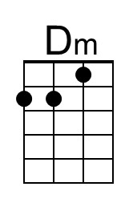 | 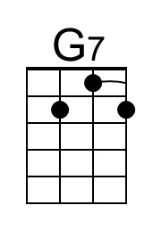 | 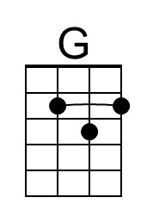 | 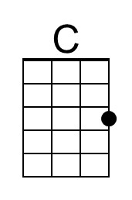 | 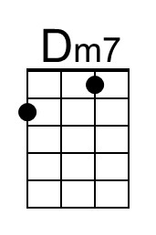 |  | 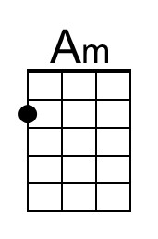 | 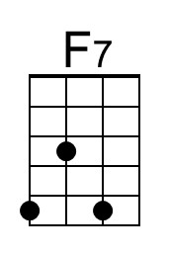 | 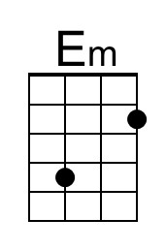 | 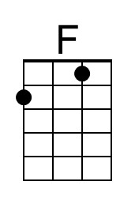
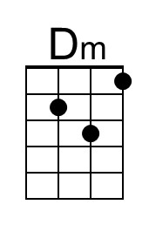 | 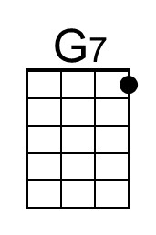 | 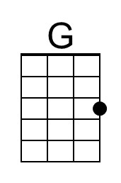 | 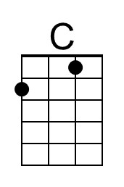 | 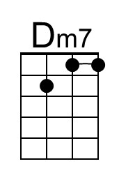 |  | 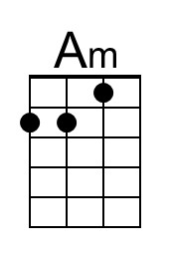 | 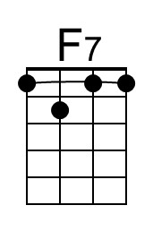 | 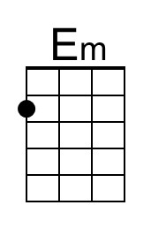 | 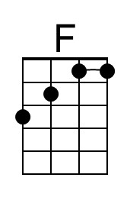

Joseph Dearest, Joseph Mine
C118 G
Lyrics: Leipzig mystery play lullaby circa 1500, Josef, Lieber Josef Mein
Music: "Resonet in Laudibus", 14th Century German carol
Joseph Dearest, Joseph Mine by the Choir of the Second Church

Intro Last 2 lines of Verse  G C G  "Joseph dearest, Joseph mine,  G C G  Help me cradle the child di-vine;  Am D7 Am D  God re-ward thee and all that's thine  G Am7 D G | G  In paradise." So prays the mother Mary.  Chorus  D Em C7  He came a-mong us at Christmas-tide,  Em C7 Am7 D  At Christmas-tide, in Bethle-hem;  G D G  Men shall bring Him from far and wide  D G D G Bm Em  Love's dia-dem: Je - sus, Je - sus,  C G C D7  Lo, He comes, and loves, and saves,  G | G  and frees us!  G C G  "Gladly, dear one, lady mine,  G C G  I will cradle this child of thine;  Am D7 Am D  God's own light on us both shall shine  G Am7 D G | G  In paradise.” As prays the mother Mary.  Chorus |  |  |  |  | G C G  Now is born Em-manu-al,  G C G  Prophesied once by E-zeki-el,  Am D7 Am D  Promised Mary by Gabri - el,  G Am7 D G | G  Ah, who can tell Thy praises, Son of Mary.  Chorus  G C G  All shall come and bow the knee,  G C G  Wise and happy their souls shall be.  Am D7 Am D  Loving such a di - vini - ty  G Am7 D G | G  As all may see in Jesus, Son of Mary. Chorus  G C G  Sweet and lovely little one,  G C G  Thou princely, beautiful, God’s own Son,  Am D7 Am D  Without thee all of us were un-done;  G Am7 D G | G  Our love is won by thee, O Son of Mary.  Chorus
 | 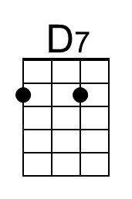 | 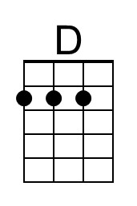 |  | 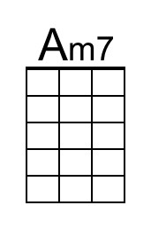 |  |  | 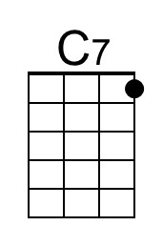 | 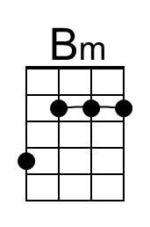
 | 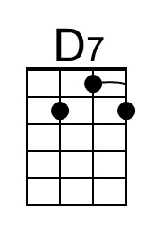 | 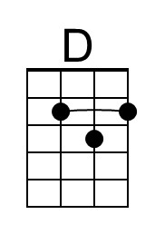 |  | 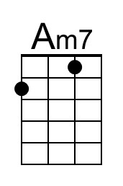 |  |  | 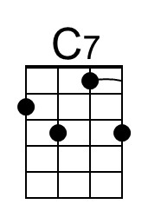 | 