Joy To The World
C12 C
Lyrics by Isaac Watts (1719); Music "Antioch" by Lowell Mason (1848)

Intro (Chords to last line of verse) C F C F C G C  C G C F C G C  Joy to the world ! The Lord is come,  F G C  Let earth receive her King !  F C F C  Let ev'ry heart, prepare Him room.  G  And heav'n and nature sing, and heav'n and nature sing,  C F C F C G C  and heaven and heaven and na-ture sing.  C G C F C G C  Joy to the earth ! The Savior reigns,  F G C  Let men their songs employ !  F C F C  While fields and floods, rocks, hills, and plains,  G  Repeat the sounding joy, repeat the sounding joy,  C F C F C G C  Repeat, re-peat the sound-ing joy.  C G C F C G C  He rules the world with truth and grace,  F G C  And makes the nations prove,  F C F C  The glories of His righteousness,  G  And wonders of His love, and wonders of His love,  C F C F C G C  And wo...nders, and wo-n-de...rs of His love. | 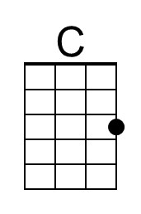
 | 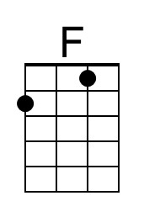
 | 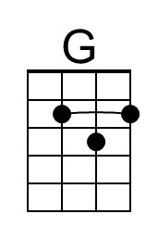
 | Baritone
 | 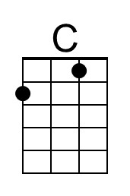
 | 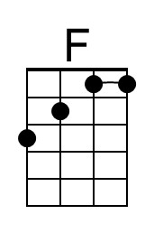
 | 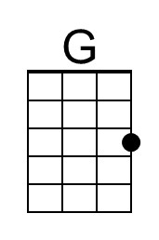

Joy To The World
C12 F
Lyrics by Isaac Watts (1719); Music "Antioch" by Lowell Mason (1848)

Intro (Chords to last line of verse) F Bb F Bb F C F

F C F Bb F C F
Joy to the world ! The Lord is come,
Bb C F
Let earth receive her King !
Bb F Bb F
Let ev'ry heart, prepare Him room.
C
And heav'n and nature sing, and heav'n and nature sing,
F Bb F Bb F C F
and heaven and hea-ven and na-ture sing.

F C F Bb F C F
Joy to the earth ! The Sav-ior reigns,
Bb C F
Let men their songs employ !
Bb F Bb F
While fields and floods, rocks, hills, and plains,
C
Repeat the sounding joy, repeat the sounding joy,
F Bb F Bb F C F
Repeat, re - peat the sound-ing joy.

F C F Bb F C F
He rules the world with truth and grace,
Bb C F
And makes the nations prove,
Bb F Bb F
The glories of His righteous-ness,
C
And wonders of His love, and wonders of His love,
F Bb F Bb F C F
And won - ders, and wo-n-de...rs of His love.
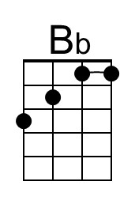
Baritone
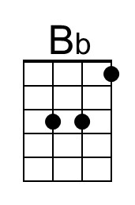

Joy To The World
C12 G
Lyrics by Isaac Watts (1719); Music "Antioch" by Lowell Mason (1848)

Intro (Chords to last line of verse) G C G C G D G

G D G C G D G
Joy to the world ! The Lord is come,
C D G
Let earth receive her King !
C G C G
Let ev'ry heart, prepare Him room.
D
And heav'n and nature sing, and heav'n and nature sing,
G C G C G D G
and heaven and heaven and na-ture sing.

G D G C G D G
Joy to the earth ! The Savior reigns,
C D G
Let men their songs employ !
C G C G
While fields and floods, rocks, hills, and plains,
D
Repeat the sounding joy, repeat the sounding joy,
G C G C G D G
Repeat, re-peat the sound-ing joy.

G D G C G D G
He rules the world with truth and grace,
C D G
And makes the nations prove,
C G C G
The glories of His righteousness,
D
And wonders of His love, and wonders of His love,
G C G C G D G
And wo...nders, and wo-n-de...rs of His love.
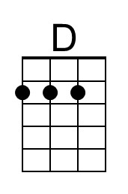
Baritone
