**Jug Band Music (John Sebastian)**

**C**

I was down in Savannah, eatin' cream and bananas

**G7**

When the heat just made me faint

I began to get cross-eyed, I thought I was lost, I'd

**C**

Begun to see things as they ain't

As the relatives gathered to see what's the matter

**D7**

The doctor came to see was I dyin'

**C**

But the doctor said, "Give him jug band music

**G7 C**

It seems to make him feel just fine"

**G7**

I was told a little tale about a skinny-as-a-rail

**C**

Eight-foot cowboy with a headache

**G7**

He was hung up in the desert swattin' rats and tryin' to get a drink of water

**C**

With his knees a-gettin' mud-caked

And I'll tell you in a sentence how he stumbled into Memphis, Tennessee

**F**

Hardly crawlin', lookin' dust-baked

We gave him a little water, a little bit of wine

**C**

He opened up his eyes, but they didn't seem to shine

Then the doctor said, "Give him jug band music

**G7 C**

It seems to make him feel just fine"

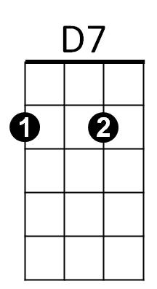

F

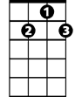

G7



C

**C**

So if you ever get sickly, get Sis to run quickly

**G7**

To the dusty closet shelf

And pull out a washboard, and play a guitar chord

**C**

And do a little do-it-yourself

And call on your neighbors to put down their labors

**D7**

And come and play the hardware in time

**C**

'Cause the doctor said, "Give him jug band music

**G7 C**

It seems to make him feel just fine"

**G7**

I was floatin' in the ocean greased with suntan lotion

**C**

When I got wiped out by a beach boy

**G7**

He was surfin' when he hit me but jumped off his board to get me

**C**

And he dragged me by the armpit like a child's toy

As we staggered into land with all the waiters eatin' sandwiches

**F**

He tried to mooch a towel from the hoi polloi

He emptied out his eardrums, I emptied out mine

**C**

And everybody knows that the very last line

Is "the doctor said, 'Give him jug band music

**G7 C**

It seems to make him feel just fine"

**C**

And the doctor said "give him jug band music

**G7 C**

It seems to make him feel just fine"

**BARITONE**



D7

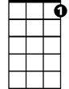

G7



F

C

