**Junk Food Junkie (Larry Groce)**

**C**



C

You know I love that organic cooking,

**F C**

I always ask for more.

**A7**

And they call me Mr. Natural,

F



**D7 G**

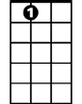

A7

On down to the health food store.

**C**

I only eat good sea salt,

**F C**

White sugar don't touch my lips.

**A7**

And my friends are always begging me to take them

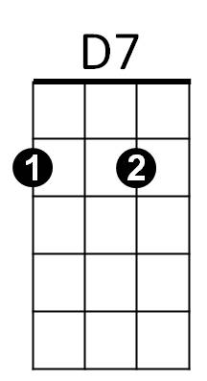**D G C Am**

On macrobiotic trips, Yes, they are.

**Am**

Oh, but at night I take out my strongbox,

**Dm Am**

That I keep under lock and key.



G

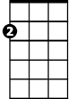

Am

And I take it off to my closet,

**B7 E7**

Where nobody else can see.

**Am**

I open that door so slowly,

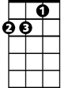

Dm

**Dm Am**

Take a peek up north and south.

**C A7**

Then I pull out a Hostess Twinkie,

**D7 G C**

And I pop it in my mouth.

E7

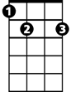

**CHORUS:**

**F C**

Yeah, in the daytime I'm Mr. Natural,

**G C**

Just as healthy as I can be.

**Am**

But at night I'm a junk food junkie,

**E7 Am**

Good Lord have pity on me.

**C**

Well, at lunchtime you can always find me,

**F C**

At the Whole Earth Vitamin Bar.

**A7**

Just sucking on my plain white yogurt,

**D7 G**

From my hand thrown pottery jar.

**C**

And sippin' a little hand pressed cider,

**F C**

With a carrot stick for dessert.

**A7**

And wiping my face in a natural way,

**D7 G C Am**

On the sleeve of my peasant shirt. Oh yeah!

**Am**

Ah, but when that clock strikes midnight

**Dm Am**

And I'm all by myself.

**B7 E7**

I work that combination, on my secret hideaway shelf.

**Am**

**BARITONE**

And I pull out some Fritos co rn chips,

**Dm Am**

C



Dr. Pepper and an ol' Moon Pie.

**C A7**

Then I sit back in glorious expectation,

**D7 G C**

Of a genuine junk food high.

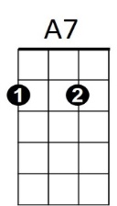



F

**(CHORUS)**

**C**

My friends down at the commune,

**F C**

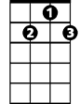

D7

They think I'm pretty neat.

**A7**

Oh, I don't know nothing about arts and crafts,

**D7 G**

But I give 'em all something to eat.

**C**



G

I'm a friend to old Euell Gibbons,

**F C**

And I only eat homegrown spice.

**A7**

I got a John Keats autographed Grecian urn,

**D7 G C Am**



Am

Filled up with my brown rice. Yes, I do.

**Am**

Oh, but folks, lately I have been spotted,

**Dm Am**

With a Big Mac on my breath.

B7

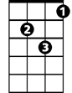

Dm

Stumbling into a Colonel Sanders,

**B7 E7**

With a face as white as death.

**Am**

I'm afraid someday they'll find me,



E7

**Dm Am**

Just stretched out on my bed.

**C A7**

With a handful of Pringles Potato Chips,

**D7 G C**

And a Ding Dong by my head.

**(CHORUS) (Last line slowly)**