**Just like Romeo and Juliet (Freddie Gorman and Bob Hamilton)**

**Intro: C F / C F/ C F C F**

(Ooh-oo-oo hoo hoo)

**C F C F**

Findin' a job tomorrow mornin'

**C F C F**

Got a little somethin' I wanna do

**C F C F**

Gonna buy somethin' I could ride in

**C F C F**

A-Take my girl datin' at the drive-in

**Dm Em F**

Our love's gonna be written down in history

**G7 C F C F C F C F**

A-Just like Romeo and Juliet

**C F C F**

I'm gonna buy her pretty presents

**C F C F**

Just like the ones in a catalog

**C F C F**

Gonna show how much I love her

**C F C F**

Let her know one way or the other

**Dm Em F**

Our love's gonna be written down in history

**G7 C**

A-Just like Romeo and Juliet

**C F C F**

Ooh-oo-ooh-hoo hoo

**C F C F**

Dooo, doot, doot, doot, doot, doot, doot, doo-doop

**C F C F 4X**

**BARITONE**

Just Like Romeo and Juliet

**Am**

Talk about love and romance

**G#**

Just wait 'til I get myself straight

**G**

I'm gonna put Romeo's fame

**G7**

Right smack-dab on a date

**C F C F**

Ah, all right, now, I'm speculatin'

**C F C F**

Wonder what tomorrow's gonna really bring

**C F C F**

If I don't find work tomorrow

**C F C F**

It's gonna be heartaches 'n' sor-row

**Dm Em F**

Our love's gonna be destroyed like a tragedy

**G7 C**

A-Just like Romeo and Juliet

**C F C F**

Ooh-oo-ooh-hoo hoo

**C F C F**

Dooo, doot, doot, doot, doot, doot, doot, doo-doop

**F C F 4X**

Just Like Romeo and Juliet

Em

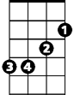

C

F

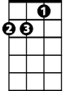

Dm

C



Am



F

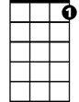

G7

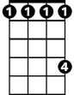

G#

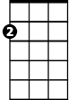

Em

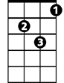

Dm



G



G

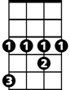

G#



Am

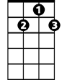

G7