Just My Imagination (Running Away With Me) (Norman Whitfield - Barrett Strong) (C)

C F C F  Ooo ooo ooooo, ooooooo  C F C F  Each day through my window I watch up as she passes by  C F C F  I say to myself, you’re such a lucky guy  C F C F  To have a girl like her is truly a dream come true  C F C F  Out of all the fellas in the world, she belongs to you  Chorus:  C F C F  But it was just my imagination runnin' away with me.  C F C F  It was just my imagina-tion runnin' away with me  C F C F  (Soon) Soon we'll be married and raise a family (wo yeah)  C F C F  A cozy little home out in the country, with two children, maybe three.  C F C F  I tell you, I ---- can visualize it all.  C F C F  This couldn't be a dream, for too real it all seems. Chorus:  C F  Every night, on my knees, I pray, “Dear Lord, hear my plea  C F G7  Don't ever let another take her love from me, or I would surely die.  C F  (Her love is) heavenly, when her arms enfold me  C F C F C F  I hear a tender rhapsody, but in reality, she doesn't even know me  C F C F  But it was just my imagination, once again, runnin' away with me  C F C  It was just my imagina-tion runnin' away with me.  F  (Oh I never met her but I can’t forget her)  (Repeat Chorus to fade) | 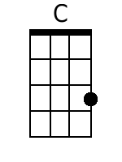
 | 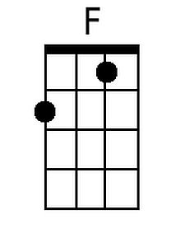
 | 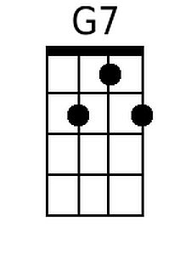
 | Bari
 | 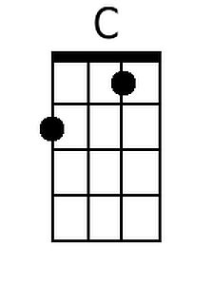
 | 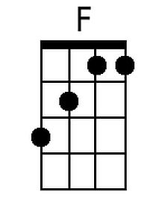
 | 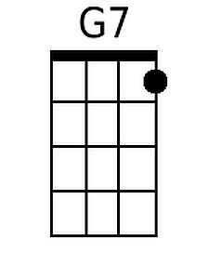

Just My Imagination (Running Away With Me) (Norman Whitfield - Barrett Strong) (G)

G C G C  Ooo ooo ooooo, ooooooo  G C G C  Each day through my window I watch up as she passes by  G C G C  I say to myself, you're such a lucky guy  G C G C  To have a girl like her is truly a dream come true  G C G C  Out of all the fellas in the world, she belongs to you  Chorus:  G C G C  But it was just my imagination runnin' away with me.  G C G C  It was just my imagina-tion runnin' away with me.  G C G C  (Soon) Soon we'll be married and raise a family (wo yeah)  G C G C  A cozy little home out in the country, with two children, maybe three.  G C G C  I tell you, I------can visualize it all  G C G C  This couldn't be a dream, for too real it all seems. Chorus.  G C  Every night, on my knees, I pray, “Dear Lord, hear my plea  G C D7  Don't ever let another take her love from me, or I would surely die.  G C  (Her love is) heavenly, when her arms enfold me  G C G C G C  I hear a tender rhapsody, but in reality, she doesn't even know me  G C G C  But it was just my imagination, once again, runnin' away with me  G C G  It was just my imagina-tion runnin' away with me  C  (Oh I never met her but I can't forget her)  (Repeat Chorus to fade) | 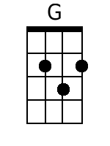
 | 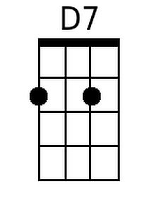
 | Bari
 | 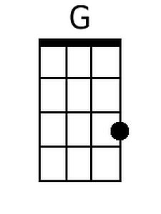
 | 