**Just One Look (G. Carroll / D. Payne)**

**Intro: C F C G7**

**C Am**

Just one look and I fell so ha - ar - ard

**F G**

In love with you oh ~ oh

**C Am**

I found out how good it fee - ee - eels

**F G**

To have your love oh ~ oh

**C Am**

Say you will, will be mi - i - ine

**F G**

For-ever and al-ways oh ~ oh

**C Am**

Just one look and I knew - ne – new

**F G C C7**

That you were my only one oh oh oh

**F**

I thought I was dreaming

**C**

But I was wrong oh yeah , yeah

**D7**

Ah but I'm gonna keep on scheming

**G**

‘til I can make you, make you my own

**C Am**

So you see I really ca - a - are

**F G**

With-out you, I'm nothing oh oh

**C Am**

Just one look and I know - o - ow

**F G**

I'll get you some-day oh oh

**C F G**

Just one look - that's all it took Yeah

**C F G**

Just one look - that's all it took Well

**C F G**

Just one look - that's all he wrote, baby

**C F G**

Just one look - that's all it took

**C F C G7 C**

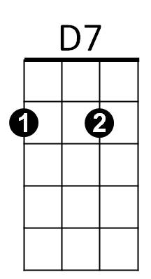



C

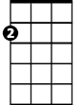

Am

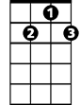

G7

F



G

**BARITONE**

C



F

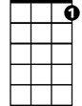

G7

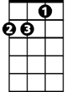

Am



G



D7