**Keep on the Sunny Side (Ada Blenkhorn / J Howard Entwisle) Key C**

**Intro: (Chords for last line of chorus) C G7 C**

F

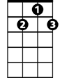

G7



C

**C F C**

Well there's a dark and a troubled side of life.

**G7**

There's a bright and a sunny side too.

**C**

Though we meet with the darkness and strife,



G

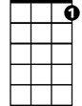

C7

**G7 C**

The sunny side we also may view.

**Chorus:**

**C7 F C**

Keep on the sunny side, always on the sunny side,

**G G7**

Keep on the sunny side of life.

**C C7 F C**

It will help us every day, it will brighten all the way,

**G7 C**

If we keep on the sunny side of life.

**C F C**

Oh, the storm and its fury broke today,

**G7**

Crushing hopes that we cherish so dear.

**C**

Clouds and storms will in time pass away.

**BARITONE**

**G7 C**



F



G7

C



The sun again will shine bright and clear.

**(Chorus)**

**C F C**

Let us greet with a song of hope each day.



G

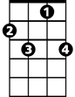

C7

**G7**

Though the moments be cloudy or fair.

**C**

Let us trust in our Savior always,

**G7 C**

To keep us, every one, in His care.

**(Chorus)**

**C G7 C**

If we'll keep on the sunny side of life.

**Keep on the Sunny Side (Ada Blenkhorn / J Howard Entwisle) Key D**

**Intro: (Chords for last line of chorus) D A7 D**



G

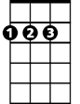

D

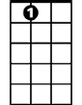

A7

**D G D**

Well there's a dark and a troubled side of life.

**A7**

There's a bright and a sunny side too.

**D**

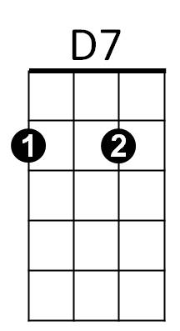Though we meet with the darkness and strife,

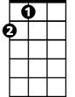

A

**A7 D**

The sunny side we also may view.

**Chorus:**

**D7 G D**

Keep on the sunny side, always on the sunny side,

**A A7**

Keep on the sunny side of life.

**D D7 G D**

It will help us every day, it will brighten all the way,

**A7 D**

If we keep on the sunny side of life.

**D G D**

Oh, the storm and its fury broke today,

**A7**

Crushing hopes that we cherish so dear.

**D**

Clouds and storms will in time pass away.

**BARITONE**

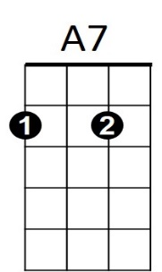 **A7 D**



G



D

The sun again will shine bright and clear.

**(Chorus)**

**D G D**

Let us greet with a song of hope each day.



D7



A

**A7**

Though the moments be cloudy or fair.

**D**

Let us trust in our Savior always,

**A7 D**

To keep us, every one, in His care.

**(Chorus)**

**D A7 D**

If we'll keep on the sunny side of life.

**Keep on the Sunny Side (Ada Blenkhorn / J Howard Entwisle) Key G**

**Intro: (Chords for last line of chorus) G D7 G**



C



G

**G C G**

Well there's a dark and a troubled side of life.

**D7**

There's a bright and a sunny side too.

**G**

Though we meet with the darkness and strife,

**D7 G**



D



G7

The sunny side we also may view.

**Chorus:**

**G7 C G**

Keep on the sunny side, always on the sunny side,

**D D7**

Keep on the sunny side of life.

**G G7 C G**

It will help us every day, it will brighten all the way,

**D7 G**

If we keep on the sunny side of life.

**G C G**

Oh, the storm and its fury broke today,

**D7**

Crushing hopes that we cherish so dear.

**G**

**BARITONE**

Clouds and storms will in time pass away.

C



D7



G

**D7 G**

The sun again will shine bright and clear.

**(Chorus)**

**G C G**

Let us greet with a song of hope each day.



D



G7

**D7**

Though the moments be cloudy or fair.

**G**

Let us trust in our Savior always,

**D7 G**

To keep us, every one, in His care.

**(Chorus)**

**G D7 G**

If we'll keep on the sunny side of life.