**Kokomo (John Phillips, Scott McKenzie, Mike Love, Terry Melcher, 1988) (C)**

**GCEA – Soprano, Concert & Tenor**

**Intro**

**C↓ F↓**

Aruba, Jamaica, ooh, I want to take ya. Ber-muda, Bahama, come on, pretty mama.

**C↓ F↓ C Cmaj**

Key Largo, Montego, baby, why don't we go, Ja-maica. Off the Florida Keys,

**Gm7**  **F Fm C D7 G**

There's a place called Kokomo, that's where you want to go to get a-way from it all.

**C Cmaj7 Gm7 F Fm C**

Bodies in the sand, tropical drink melting in your hand. We'll be falling in love

**D7 G C**

To the rhythm of a steel drum band, down in Koko-mo.

**Refrain**

**C F**

A-ruba, Jamaica, ooh, I want to take you to Ber-muda, Bahama. Come on, pretty mama.

**C Bb F**

Key Largo, Montego, oo, I wan-na take you down to Kokomo?

*ba-by, why don't we go?*

**Fm** **C**

We'll get there fast and then we'll take it slow.

**Am Dm7 G7 C**

That's where we wanna go, way down in Koko-mo.

1. *Martinique, that Montserrat mystique.*

2. *Port au Prince, I wanna catch a glimpse.* **To Bridge**

3. (**Repeat and fade**)

**C Cmaj7 Gm7 F**

We'll put out to sea and we'll perfect our chemistry.

**Fm C D7 - G C Cmaj7**

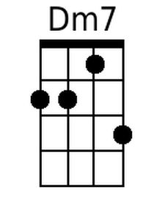 By and by we'll de-fy a little bit of gravity. | Afternoon de-light,

**Gm7 F Fm C**

cocktails and moonlit nights. That dreamy look in your eye,

**D7 G C**

Give me a tropical contact high way down in Koko-mo. **Refrain**

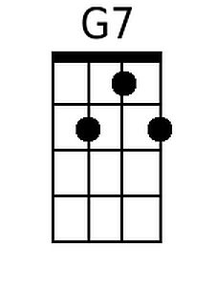**Bridge**

**C Cmaj7 Gm7 F Fm C**

Everybody knows a little place like Kokomo. Now if you wanna go

**D7 G7 C**

and get a-way from it all, Go down to Koko-mo. **Refrain**

|  |  |  |  |  |  |  |  |
| --- | --- | --- | --- | --- | --- | --- | --- |
|  |  |  |  |  |  |  |  |

**Kokomo (John Phillips, Scott McKenzie, Mike Love, Terry Melcher, 1988) (C)**

**DGBE – Baritone**

**Intro**

**C↓ F↓**

Aruba, Jamaica, ooh, I want to take ya. Ber-muda, Bahama, come on, pretty mama.

**C↓ F↓ C Cmaj**

Key Largo, Montego, baby, why don't we go, Ja-maica. Off the Florida Keys,

**Gm7**  **F Fm C D7 G**

There's a place called Kokomo, that's where you want to go to get a-way from it all.

**C Cmaj7 Gm7 F Fm C**

Bodies in the sand, tropical drink melting in your hand. We'll be falling in love

**D7 G C**

To the rhythm of a steel drum band, down in Koko-mo.

**Refrain**

**C F**

A-ruba, Jamaica, ooh, I want to take you to Ber-muda, Bahama. Come on, pretty mama.

**C Bb F**

Key Largo, Montego, oo, I wan-na take you down to Kokomo?

*ba-by, why don't we go?*

**Fm** **C**

We'll get there fast and then we'll take it slow.

**Am Dm7 G7 C**

That's where we wanna go, way down in Koko-mo.

1. *Martinique, that Montserrat mystique.*

2. *Port au Prince, I wanna catch a glimpse.* **To Bridge**

3. (**Repeat and fade**)

**C Cmaj7 Gm7 F**

We'll put out to sea and we'll perfect our chemistry.

**Fm C D7 - G C Cmaj7**

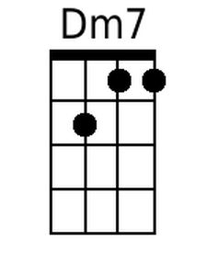 By and by we'll de-fy a little bit of gravity. | Afternoon de-light,

**Gm7 F Fm C**

cocktails and moonlit nights. That dreamy look in your eye,

**D7 G C**

Give me a tropical contact high way down in Koko-mo. **Refrain**

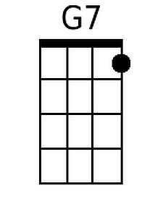**Bridge**

**C Cmaj7 Gm7 F Fm C**

Everybody knows a little place like Kokomo. Now if you wanna go

**D7 G7 C**

and get a-way from it all, Go down to Koko-mo. **Refrain**

|  |  |  |  |  |  |  |  |
| --- | --- | --- | --- | --- | --- | --- | --- |
|  |  |  |  |  |  |  |  |

**Kokomo (John Phillips, Scott McKenzie, Mike Love, Terry Melcher, 1988) (G)**

**GCEA – Soprano, Concert & Tenor**

**Intro**

**C↓ F↓**

Aruba, Jamaica, ooh, I want to take ya. Ber-muda, Bahama, come on, pretty mama.

**C↓ F↓ C Cmaj**

Key Largo, Montego, baby, why don't we go, Ja-maica. Off the Florida Keys,

**Dm7 C Cm G A7 D**

There's a place called Kokomo, that's where you want to go to get a-way from it all.

**G Gmaj7 Dm7 C Cm G**

Bodies in the sand, tropical drink melting in your hand. We'll be falling in love

**A7 D G**

To the rhythm of a steel drum band, down in Koko-mo.

**Refrain**

**G C**

A-ruba, Jamaica, ooh, I want to take you to Ber-muda, Bahama. Come on, pretty mama.

**G F C**

Key Largo, Montego, oo, I wan-na take you down to Kokomo?

ba-by, why don't we go?

**Cm G**

We'll get there fast and then we'll take it slow.

**Em Am7 D7 G**

That's where we wanna go, way down in Koko-mo.

1. *Martinique, that Montserrat mystique.*

2. *Port au Prince, I wanna catch a glimpse.* **To Bridge**

3. (**Repeat and fade**)

**G Gmaj7 Dm7 C**

We'll put out to sea and we'll perfect our chemistry.

**Cm G A7 - D G Gmaj7**

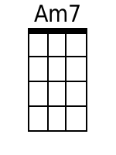 By and by we'll de-fy a little bit of gravity. | Afternoon de-light,

**Dm7 C Cm G**

cocktails and moonlit nights. That dreamy look in your eye,

**A7 D G**

Give me a tropical contact high way down in Koko-mo. Refrain

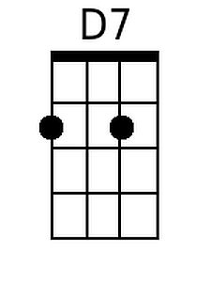

**Bridge**

**G Gmaj7 Dm7 C Cm G**

Everybody knows a little place like Kokomo. Now if you wanna go

**A7 D7 G**

and get a-way from it all, Go down to Koko-mo. **Refrain**

|  |  |  |  |  |  |  |  |
| --- | --- | --- | --- | --- | --- | --- | --- |
|  |  |  |  |  |  |  |  |

**Kokomo (John Phillips, Scott McKenzie, Mike Love, Terry Melcher, 1988) (G)**

**DGBE – Baritone**

**Intro**

**C↓ F↓**

Aruba, Jamaica, ooh, I want to take ya. Ber-muda, Bahama, come on, pretty mama.

**C↓ F↓ C Cmaj**

Key Largo, Montego, baby, why don't we go, Ja-maica. Off the Florida Keys,

**Dm7 C Cm G A7 D**

There's a place called Kokomo, that's where you want to go to get a-way from it all.

**G Gmaj7 Dm7 C Cm G**

Bodies in the sand, tropical drink melting in your hand. We'll be falling in love

**A7 D G**

To the rhythm of a steel drum band, down in Koko-mo.

**Refrain**

**G C**

A-ruba, Jamaica, ooh, I want to take you to Ber-muda, Bahama. Come on, pretty mama.

**G F C**

Key Largo, Montego, oo, I wan-na take you down to Kokomo?

ba-by, why don't we go?

**Cm G**

We'll get there fast and then we'll take it slow.

**Em Am7 D7 G**

That's where we wanna go, way down in Koko-mo.

1. *Martinique, that Montserrat mystique.*

2. *Port au Prince, I wanna catch a glimpse.* **To Bridge**

3. (**Repeat and fade**)

**G Gmaj7 Dm7 C**

We'll put out to sea and we'll perfect our chemistry.

**Cm G A7 - D G Gmaj7**

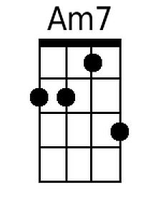 By and by we'll de-fy a little bit of gravity. | Afternoon de-light,

**Dm7 C Cm G**

cocktails and moonlit nights. That dreamy look in your eye,

**A7 D G**

Give me a tropical contact high way down in Koko-mo. **Refrain**

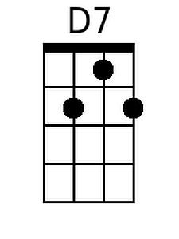**Bridge**

**G Gmaj7 Dm7 C Cm G**

Everybody knows a little place like Kokomo. Now if you wanna go

**A7 D7 G**

and get a-way from it all, Go down to Koko-mo. **Refrain**

|  |  |  |  |  |  |  |  |
| --- | --- | --- | --- | --- | --- | --- | --- |
|  |  |  |  |  |  |  |  |