**L-O-V-E (Milt Gabler / Ben Kaempfert) Key C**

**C Am7 Dm7 G7**



C

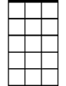

Am7

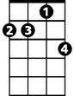

Dm7

L - is for the way you look at me

**Dm7 G7 C**

O - is for the only one I see

**C7 F**

V - is very, very, extraordinary

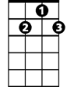

G7

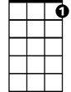

C7

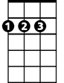

D

**D D7 G D7 G7**

E - is even more than any-one that you adore

**C Am7 Dm7 G7**

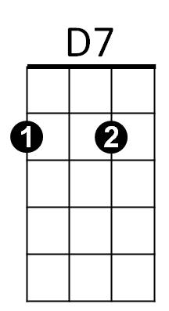Love is all that I can give to you

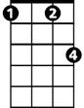

Fm

F



G

**Dm7 G7 C**

Love is more than just a game for two

**C7**

Two in love can make it -

**F Fm**

Take my heart, and please don’t break it

**C G C G**

Love was made for me and you

**Repeat song play G**

**BARITONE**

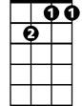

Dm7



Am7

C



**C7**

Two in love can make it -

**F Fm**

Take my heart, and please don’t break it

**C G C**



D7



F

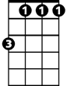

Fm



G

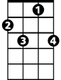

C7



G7



D

Love was made for me and you

**L-O-V-E (Milt Gabler / Ben Kaempfert) Key G**

Em7

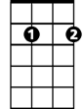

Am7



G

**BARITONE**

**G Em7 Am7 D7**

L is for the way you look at me

**Am7 D7 G**

O is for the only one I see

**G7 C**



C



G7

V is very, very extraordinary

**A A7 D A7 D7**

E is even more than any one that you adore can

**G Em7 Am7 D7**

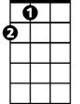

A

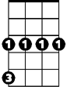

Cm



D

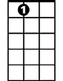

A7

Love is all that I can give to you

**Am7 D7 G**

Love is more than just a game for two

**G7**

Two in love can make it

**C Cm**

Take my heart and please don’t break it

**G D7 G D**

Love was made for me and you

**Repeat song**



Em7



Am7



G

**G7**

Two in love can make it

**C Cm**

Take my heart and please don’t break it

**G D7 G D**

C



D7



G7

Love was made for me and you

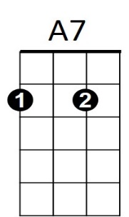



A



Cm



D