Lady Godiva (Mike Leander, Charlie Mills & Gordon Mills, 1966) (C)
Lady Godiva by Peter and Gordon (1966) (Stereo, 2011 Remaster)

C F C F  Seven-teen, a beauty queen,  C F C  she made a ride that caused  F Dm G  A scene in the town.  G7 C  Her long blonde hair,  C7 D7  hangin' down around her knees,  G7 Am7  All the cats who dig strip-tease,  C7 Dm  prayin' for a little breeze.  G C7  Her long blonde hair,  D7  falling down across her arms.  G7 C  Hiding all the lady's charms..  A D7 G7 C  Hey, hey, hey..Lady God..i. .va.  C F C F  She found fame and made her name..  C F C  A Holly-wood di-rector  F Dm G C7  Came into town ...and said to her..  D7  How'd you like to be a star?  G7 Am7  You're a girl that could go far, |  |  |  |  | C7 Dm  Especially dressed the way you are.  G C7  She smiled at him..  D7  Gave her pretty head a shake.  G7 C  That was Lady G's mis-take..  A A7 D7 G7 C  hey-hey-hey.__. Lady God..i. .va.  C F C F  He di-rects Cer-tificate X.  C F C F  And people now are craning their necks..  Dm G C7  to see her, cause she's a star...  D7  one that everybody knows.  G7 Am7  Finished with the striptease shows,  C7 Dm  Now she can afford her clothes.  G C7  Her long blonde hair,  D7  lyin' on the barber's floor.  G7 C  Doesn't need it long  A A7 D7 G7 C F C  any-more.__ Lady God...i ..va.
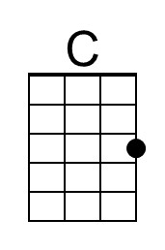 | 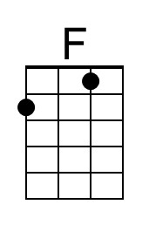 | 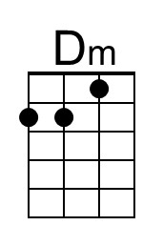 | 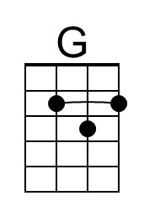 | 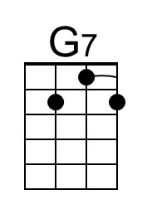 |  | 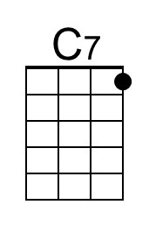 | 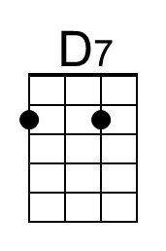 | 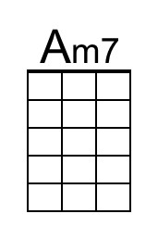 | 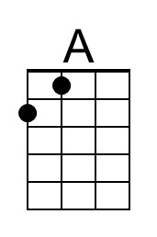
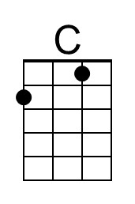 | 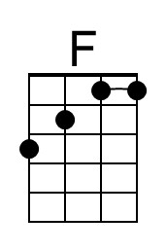 | 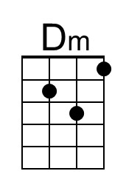 | 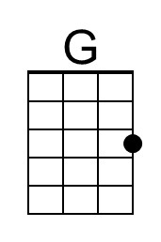 | 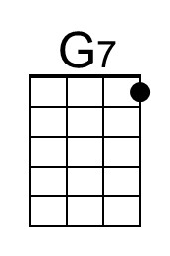 |  | 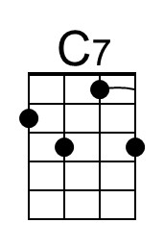 | 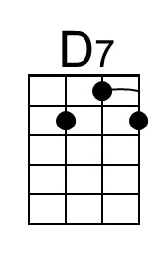 | 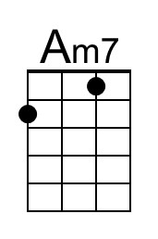 | 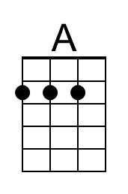

Lady Godiva (Mike Leander, Charlie Mills & Gordon Mills, 1966) (G)
Lady Godiva by Peter and Gordon (1966) (Stereo, 2011 Remaster)

G C G C  Seven-teen, a beauty queen,  G C G  she made a ride that caused  C Am D  A scene in the town.  D7 G  Her long blonde hair,  G7 A7  hangin' down around her knees,  D7 Em7  All the cats who dig strip-tease,  G7 Am  prayin' for a little breeze.  D G7  Her long blonde hair,  A7  falling down across her arms.  D7 G  Hiding all the lady's charms..  E A7 D7 G  Hey, hey, hey..Lady God..i. .va.  G C G C  She found fame and made her name..  G C G  A Holly-wood di-rector  C Am D G7  Came into town ...and said to her..  A7  How'd you like to be a star?  D7 Em7  You're a girl that could go far, |  |  |  |  | G7 Am  Especially dressed the way you are.  D G7  She smiled at him..  A7  Gave her pretty head a shake.  D7 G  That was Lady G's mis-take..  E E7 A7 D7 G  hey-hey-hey.__.Lady God..i. .va.  G C G C  He di-rects Cer-tificate X.  G C  And people now are  G C Am  craning their necks..to see her.  D G7  Cause she's a star..  A7  one that everybody knows.  D7 Em7  Finished with the striptease shows,  G7 Am  Now she can afford her clothes.  D G7  Her long blonde hair,  A7  lyin' on the barber's floor.  D7 G  Doesn't need it long  E E7 A7 D7 G C G  any-more.__ Lady God...i ..va.
 |  | 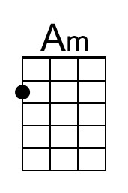 | 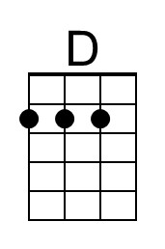 |  |  |  | 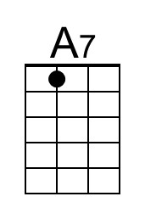 | 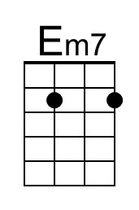 | 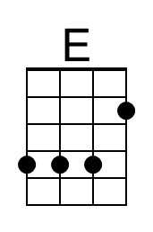
 |  | 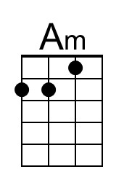 | 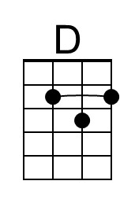 |  |  |  | 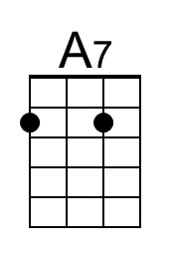 | 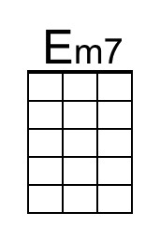 | 