Lady Marmalade (Kenny Nolan & Robert Crewe, 1974) (Am)

Intro: Am Dm

Am D Am D
Hey sister, go sister, soul sister, go sister. Hey sister, go sister, soul sister, go sister.
Am D Am D
He met marmalade down in old New Orleans, Struttin' her stuff on the street.
Dm Em E7
She said "hello, hey Joe, you wanna give it a go?"

Chorus
Am D Am D
Gitchi gitchi ya ya da da, Itchi gitchi ya ya here.
Am D Dm Am
Mocha-choca-lata ya ya, Creole Lady Marmalade.

Reprise
Am D
Voulez-vous coucher avec moi, ce soir?
Am D
Voulez-vous coucher avec moi?

Am D Am D
He sat in her boudoir while she freshened up, That boy drank all that magnolia wine
Dm Em E7
On her black satin sheets where he started to freak. Chorus

Am D Am D
Hey, hey, hey - Touch of her skin feelin' silky smooth, The colour of caf au lait.
Dm Em E7
Made the savage beast inside roar until it cried - More, more, more

Am D Am D
Now he's back home doing nine-to-five, Living his grey flannel life
Dm Em E7
But when he turns off to sleep - Old memories creep, more, more, more.
Chorus & Reprise

A hit for LaBelle in 1974. |  |  | GCEA | 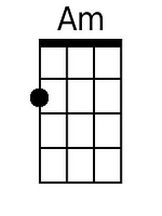 | 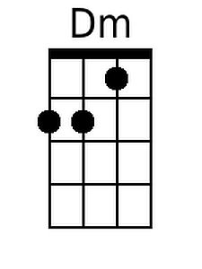 | 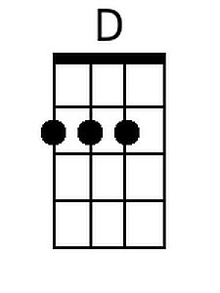 | 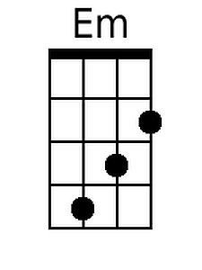 | 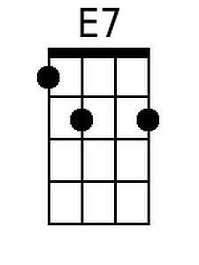
 |  |  | DGBE | 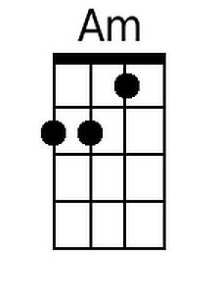 | 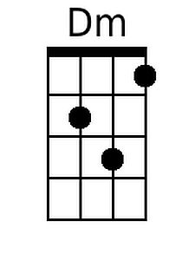 | 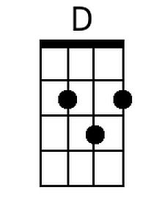 | 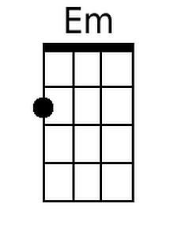 | 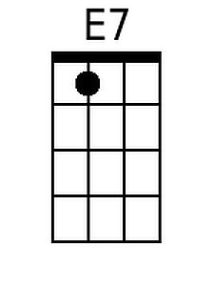


Lady Marmalade (Kenny Nolan & Robert Crewe, 1974) (Dm)

Intro: Dm Gm

Dm G Dm G
Hey sister, go sister, soul sister, go sister. Hey sister, go sister, soul sister, go sister
Dm G Dm G
He met marmalade down in old New Orleans, Struttin' her stuff on the street
Gm Am A7
She said "hello, hey Joe, you wanna give it a go?"

Chorus
Dm G Dm G
Gitchi gitchi ya ya da da, Itchi gitchi ya ya here
Dm G Gm Dm
Mocha-choca-lata ya ya, Creole Lady Marmalade

Reprise
Dm G
Voulez-vous coucher avec moi, ce soir?
Dm G
Voulez-vous coucher avec moi?

Dm G Dm G
He sat in her boudoir while she freshened up, That boy drank all that magnolia wine
Gm Am A7
On her black satin sheets where he started to freak. Chorus

Dm G Dm G
Hey, hey, hey – Touch of her skin feelin' silky smooth, The colour of café au lait.
Gm Am A7
Made the savage beast inside roar until it cried - More, more, more

Dm G Dm G
Now he's back home doing nine-to-five, Living his grey flannel life
Gm Am A7
But when he turns off to sleep - Old memories creep, more, more, more.
Chorus & Reprise

A hit for LaBelle in 1974. |  |  | GCEA |  | 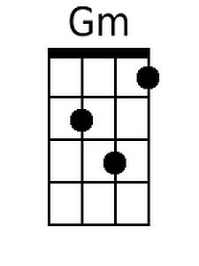 | 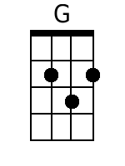 |  | 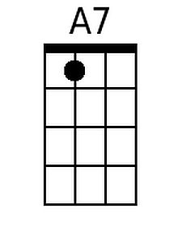
 |  |  | DGBE |  | 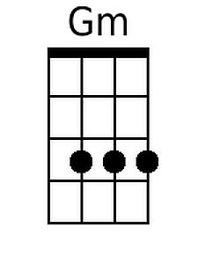 | 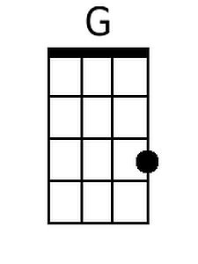 |  | 