
Last Christmas (George Michael, 1984)
C37 C

Intro Chords for Chorus  Chorus (2x)  C  Last Christmas, I gave you my heart  Am  But the very next day, you gave it away  Dm  This year, to save me from tears  G  I'll give it to someone special.  Instrumental Chorus  C  Once bitten and twice shy  Am  I keep my distance but you still catch my eye  F  Tell me baby do you recognize me?  G  Well, it's been a year, it doesn't surprise me  C  Merry Christmas, I wrapped it up and sent it  Am  With a note saying, "I Love You" I meant it  Dm  Now I know what a fool I've been  G  But if you kissed me now I know you'd  fool me again. Chorus  C  Crowded room, friends with tired eyes  Am  I'm hiding from you and your soul of ice  F  My god, I thought you were  someone to rely on  G  Me, I guess I was a shoulder to cry on | C  A face on a lover with a fire in his heart  Am  A man undercover but you tore him apart  Dm  Oh, oh, oooh  G  Now I’ve found a real love, you’ll never  fool me again. Chorus  C  A face on a lover with a fire in his heart  Am  A man undercover but you tore him apart  Dm  Next year, I'll give it to someone,  G  I'll give it to someone,  I'll give it to someone special.  Outro Instrumental Verse. End on C.
 | 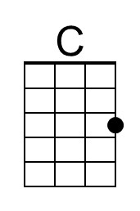 | 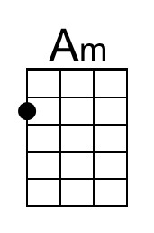 | 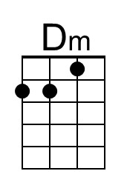
 | 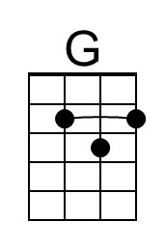 | 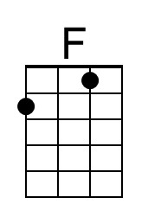
 | Baritone | 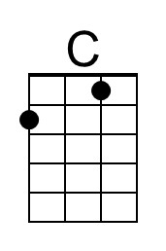 | 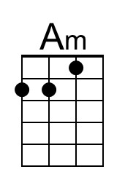 | 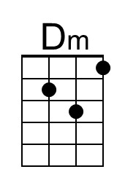
 |  | 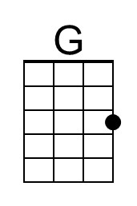 | 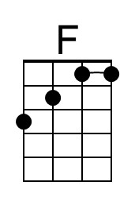

Last Christmas (George Michael, 1984)
C37 G

Intro Chords for Chorus  Chorus (2x)  G  Last Christmas, I gave you my heart  Em  But the very next day, you gave it away  Am  This year, to save me from tears  D  I'll give it to someone special.  Chorus instrumental  G  Once bitten and twice shy  Em  I keep my distance but you still catch my eye  C  Tell me baby do you recognize me?  D  Well, it's been a year, it doesn't surprise me  G  Merry Christmas, I wrapped it up and sent it  Em  With a note saying, "I Love You" I meant it  Am  Now I know what a fool I've been  D  But if you kissed me now I know you'd  fool me again. Chorus  G  Crowded room, friends with tired eyes  Em  I'm hiding from you and your soul of ice  C  My god, I thought you were  someone to rely on  D  Me, I guess I was a shoulder to cry on. | G  A face on a lover with a fire in his heart  Em  A man undercover but you tore him apart  Am  Oh, oh, oooh  D  Now I’ve found a real love,  you’ll never fool me again. Chorus  G  A face on a lover with a fire in his heart  Em  A man undercover but you tore him apart  Am  Next year, I'll give it to someone,  D  I'll give it to someone,  I'll give it to someone special.  Outro Instrumental Verse. End on G.
 |  | 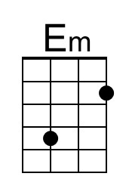
 | 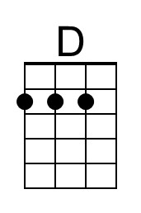
 | Baritone |  | 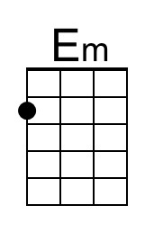
 |  | 