Last Farewell
By Randy Sparks
Key of A Minor, Shifting to the relative Major of C Major, then Shifting to B♭ Minor.
4/4 Time
Baritone Ukulele

Notes to Original Lyrics and Chords in the Key of Dm (1 Flat):

Initial Progression:
Assuming that we are in the key of Dm, the leading chord is VII, followed by I iv VI VII [(C7) Dm Gm Bb C7]. If in the Key of Am, the progression would be (G7) Am Dm F G7.

At the Instrumental Solo (a bridge), we shifted to the relative major, F Major. Note the ascending root chord progression of (V7) I ii III IV V7, ending with a I – vi turnaround (F Dm7), thus: I ii III IV V7 I vi7.
That A chord could also be an Am.

At the beginning of the Third Verse.
Key Change down a full tone from F Major – or up a half tone from D Minor – to E♭ Minor(Six Flats!). Good luck with some of these chords on the Bari Uke.
Last Farewell

By Randy Sparks
Key of A Minor; 4/4 Time; Baritone Ukulele
The lyrics are set to the traditional tune for “The Water is Wide” or “O Waly Waly.”
Recorded by The New Christy Minstrels on their 1963 album Ramblin'

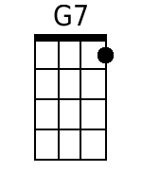 |  | G7 Am-Dm F G7  1. I'm going a - way at even-tide,  Am-Dm7 B♭ C G7  Across the wild and the rollin' sea.  C - Dm E - F  I bid you stay, here by my side  G7 C  And share a last farewell with me.  G7 Am - Dm F G7  2. Through snow-clad moun-tains proud and tall  Am-Dm7 B♭ C G7  Or a thousand miles 'cross the burning sand  C - Dm E - F  Our last fare-well then will I re-call  G7 C G7  When I'm a-lone in a far off land.  [Instrumental Solo (Harmonica indicated on original sheet music)]
  C | Dm | E | F
  G7 | G7 | C | Am7
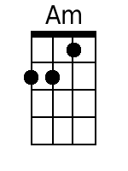 | 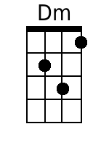
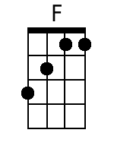 | 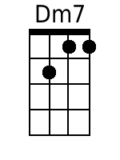
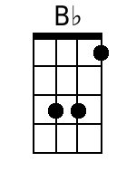 | 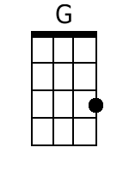
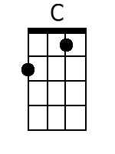 | 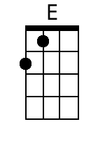
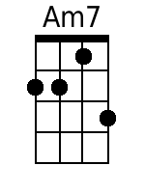

B♭ Minor |  | [Key Change up a half tone to B♭ Minor.]  B♭m-B♭m7 F# A♭7  3. A wand'rin' song is all I know  B♭m – E♭m7 G A♭-A♭7  Yet I love you more, more than words can tell  D♭-E♭m F-F#  I hear the call and I'm bound to go  A♭7 D♭  I leave you now with a last farewell.  A♭7 D♭  I leave you now with a last farewell.
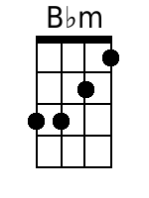 | 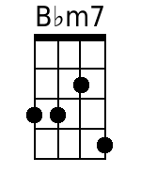
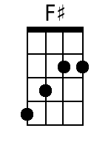 | 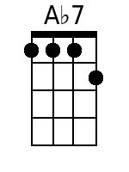
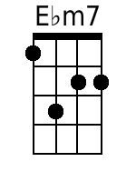
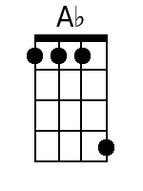 | 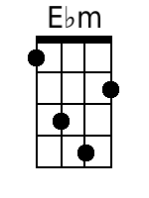
 | 