Last Farewell
By Randy Sparks
Original Key of D Minor, Shifting to F Major, and then Shifting to E♭ Minor.
4/4 Time
GCEA Ukulele

Notes.
Initial Progression:
Assuming that we are in the key of Dm, the leading chord is VII, followed by I iv VI VII [(C7) Dm Gm Bb C7]. If in the Key of Am, the progression would be (G7) Am Dm F G7.

At the Instrumental Solo (a bridge), we shifted to the relative major, F Major. Note the ascending root chord progression of (V7) I ii III IV V7, ending with a I – vi turnaround (F Dm7), thus: I ii III IV V7 I vi7.
That A chord could also be an Am.

At the beginning of the Third Verse.
Key Change down a full tone from F Major – or up a half tone from D Minor – to E♭ Minor(Six Flats!). Good luck with some of these chords on the Bari Uke.
Last Farewell

By Randy Sparks
Key of D Minor (1 Flat); 4/4 Time; “Tenderly;” GCEA Ukulele
The lyrics are set to the traditional tune for “The Water is Wide” or “O Waly Waly.”
Recorded by The New Christy Minstrels on their 1963 album Ramblin'

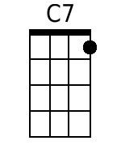 |  | C7 Dm-Gm B♭ C7  1. I'm going a - way at even-tide,  Dm-Gm7 E♭ C C7  Across the wild and the rollin' sea.  F - Gm A - B♭  I bid you stay, here by my side  C7 F  And share a last farewell with me.  C7 Dm - Gm B♭ C7  2. Through snow-clad moun-tains proud and tall  Dm-Gm7 E♭ C C7  Or a thousand miles 'cross the burning sand  F - Gm A - B♭  Our last fare-well then will I re-call  C7 F C7  When I'm a-lone in a far off land.  8 Measure Instrumental Solo (Harmonica indicated on original sheet music).
  F | Gm | A | B♭
  C7 | C7 | F | Dm7
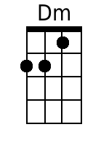 | 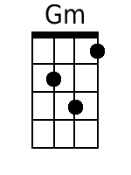
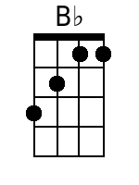 | 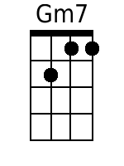
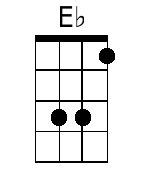 | 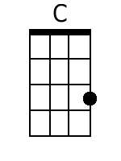
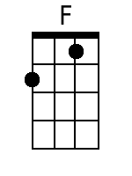 | 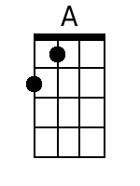
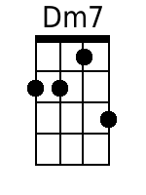

Eb Minor  Six Flats |  | [Key change to E♭ Minor]  E♭m-E♭m7 B D♭7  3. A wand'rin' song is all I know  E♭m – A♭m7 E D♭-D♭7  Yet I love you more, more than words can tell  G♭-A♭m B♭-B  I hear the call and I'm bound to go  D♭7 G♭  I leave you now with a last farewell.  D♭7 G♭  I leave you now with a last farewell.
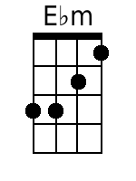 | 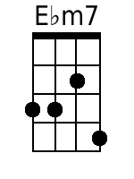
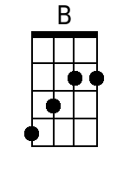 | 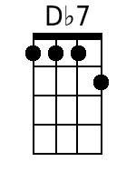
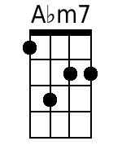 | 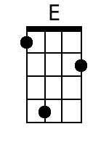
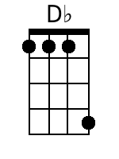 | 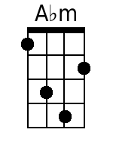
 | 