**Laughter in the Rain (Neil Sedaka / Phil Cody) Key C**

**Intro: C**

**C Dm**

Strolling along country roads with my baby,

**G7 C**

It starts to rain, it begins to pour,

**C Dm**

Without an umbrella we're soaked to the skin,

**G7 C**

I feel a shiver run up my spine,

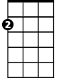

Am

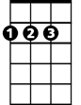

D

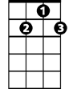

G7

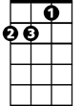

Dm



C

**Am D G**

I feel the warmth of her hand in mine.

**Chorus:**

**Fm Gm**

Oo I hear laughter in the rain,

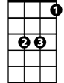

Eb

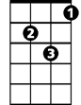

Gm

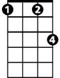

Fm



G

**Fm Eb**

Walking hand in hand with the one I love,

**Fm Gm**

Oo how I love those rainy days,

**Fm G**

And the happy way I feel inside.

**C Dm**

After a while we run under a tree,

**G7 C**

I turn to her and she kisses me.

**C Dm**

There with the beat of the rain on the leaves,

**G7 C**

Softly she breathes and I close my eyes,

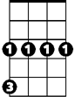

Gm

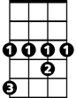

Eb



G

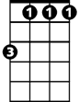

Fm



G7



D



Am



Dm

C



**BARITONE**

**Am D G**

Sharing our love under stormy skies.

**(Chorus)**

**C Dm**

Strolling along country roads with my baby,

**G7 C**

It starts to rain, it begins to pour,

**C Dm**

Without an umbrella we're soaked to the skin,

**G7 C**

I feel a shiver run up my spine,

**Am D G**

I feel the warmth of her hand in mine.

**(Chorus) (2x fade out )**

**Laughter in the Rain (Neil Sedaka / Phil Cody) Key G**

**Intro: G**

**G Am**

Strolling along country roads with my baby,

**D7 G**

It starts to rain, it begins to pour,

**G Am**

Without an umbrella we're soaked to the skin,

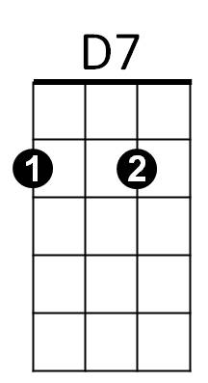**D7 G**

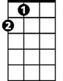

A

Em

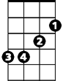

G



Am

I feel a shiver run up my spine,

**Em A D**

I feel the warmth of her hand in mine.

**Chorus:**

**Cm Dm**



Bb



Dm



Cm



D

Oo I hear laughter in the rain,

**Cm Bb**

Walking hand in hand with the one I love,

**Cm Dm**

Oo how I love those rainy days,

**Cm D**

And the happy way I feel inside.

**G Am**

After a while we run under a tree,

**D7 G**

I turn to her and she kisses me.

**G Am**

There with the beat of the rain on the leaves,

**BARITONE**

**D7 G**



Em



D7



Am



G



Cm



Dm



Bb

Softly she breathes and I close my eyes,



A

**Em A D**

Sharing our love under stormy skies.

**(Chorus)**

**G Am**



D

Strolling along country roads with my baby,

**D7 G**

It starts to rain, it begins to pour,

**G Am**

Without an umbrella we're soaked to the skin,

**D7 G**

I feel a shiver run up my spine,

**Em A D**

I feel the warmth of her hand in mine.

**(Chorus) (2x fade out )**