**Laurie (Strange Things Happen in this World) (Milton Addington)**



C



G

F



Em

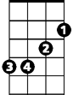

**C Am F G**

Last night at the dance I met Laurie,

**C Em F G**

So lovely and warm, an ange l of a girl.

**C C7 F Fm**

Last night I fell in love with Laurie -

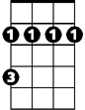

Bm

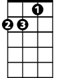

Dm

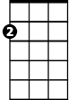

Am

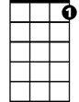

C7

**C Am Dm F G**

Strange things happen in this world.

**C Am F G**

As I walked her home, she said it was her birthday.

**C Em F G**

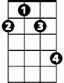

F#m

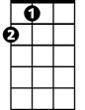

A

I pulled her close and said, "Will I see you anymore?"

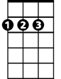

D

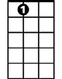

A7

**C C7 F Fm**

Then suddenly she asked for my sweater

**C Am Dm G C C7**

And said that she was very, very cold.

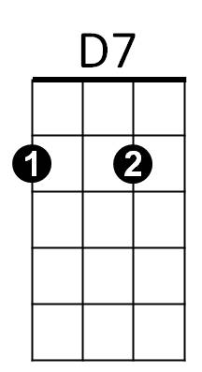 **F C C7**

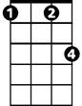

Fm

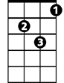

Gm

I kissed her good n ight at her door and started home,

**F C C7**

T hen thought about my sweater and went right back instead.

**F C Am**

I knocked at her door and a man appeared.

**D7 F G**

I told why I'd come, then he said:

**BARITONE**



G

C



F



Em

**C Am F G**

"You're wrong, son, you weren't with my daughter.

**C Em F G**

How can you be so cruel to come to me this way?

**C C7 F Fm**

My Laurie left this world on her birthday -

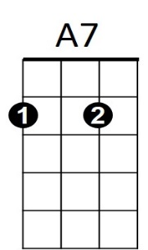 **C Am Dm Em A7**

Bm

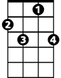

C7



Am



Dm

She died a year ago today."

**D Bm G A**

A strange force drew me to the graveyard.

**D F#m G A**

I stood in the dark, I saw the shadows wave,

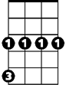

Gm

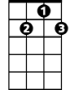

D7



F#m



A



D

**D D7 G Gm**

And then I looked and saw my sweater

**D G D D7**

Lyin' there upon her grave.

**G A G D**

Strange things happen in this - world.