**The Leaves That Are Green (Paul Simon)**

**Intro: C Dm G C / C F G C**

**C Dm G C**

I was twenty-one years when I wrote this song

**C F G C**

I'm twenty-two now, but I won't be for long

**F G**



G

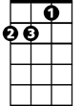

Dm



C

Time hurries on

**Chorus:**

**C G F G C**

And the leaves that are green turn to brown

**Am**

Em

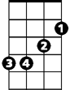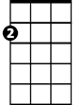

Am

F



And they wither with the wind

**Dm G**

And they crumble in your hand.

**C Dm G C**

Once my heart was filled with the love of a girl

**C F G C**

I held her close, but she faded in the night

**F G**

Like a poem I meant to write

**(Chorus)**

**BARITONE**

**C Dm G C**



G

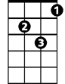

Dm

C



I threw a pebble in a brook

**C F G C**

And watched the ripples run away

**F G**

And they never made a sound



Em



Am



F

**(Chorus)**

**C Dm G C**

Hello, hello, hello, hello

**C Em F C**

Goodbye, goodbye, goodbye, goodbye

**F G**

That's all there is

**C G F G C**

And the leaves that are green turn to brown.