**Let It Snow (Sammy Cahn/Julie Styne)**

C 32

**C G7 C**



C



G

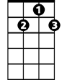

G7

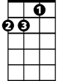

Dm

Oh, the weather outside is frightful

**Dm G**

But the fire is so delightful

**Dm A7 Dm**

And since we’ve no place to go

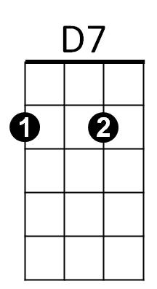 **G7 C G G7 C**

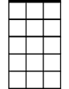

Am7

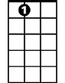

A7

Let it snow, let it snow, let it snow

**C G7 C**

It doesn’t show signs of stopping

**Dm G**

And I’ve brought some corn for popping

**Dm A7 Dm**

The lights are turned way down low

**G7 C G G7 C**

Let it snow, let it snow, let it snow

**Chorus:**

**G7 Am7 D7 G**

When we finally kiss goodnight, how I’ll hate going out in the storm

**A7 D7 G G7**

But if you’ll really hold me tight, all the way home I’ll be warm

**BARITONE**

**C G7 C**



G

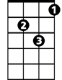

Dm

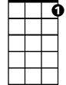

G7

C



The fire is slowly dying

**Dm G**

And my dear, we’re still good-bye-ing

**Dm A7 Dm**

As long as you love me so

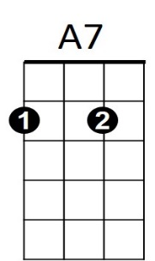 **G7 C G G7 C**

Let it snow, let it snow, let it snow. **Chorus**



D7

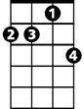

Am7

**C G7 C**

The fire is slowly dying

**Dm G**

And my dear, we’re still good-bye-ing

**Dm A7 Dm**

As long as you love me so

**G7 A7** **(Pause)**

Let it snow, let it snow, let it snow-

**G7 C G G7 C**

Let it snow, let it snow, let it snow