**Let it Be Me (Gilbert Becaud / Pierre Delanoe)**

**C G7**

Em

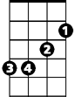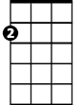

Am

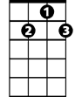

G7



C

I bless the day I found you

**Am Em**

I want to stay around you

**F C**

And so I beg you

**F G7**

E7

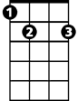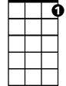

C7

F



Let it be me

**C G7**

Don't take this heaven from one

**Am Em**

If you must cling to someone

**F C**

Now and forever

**F C C7**

Let it be me

**Reprise:**

**F Em**

Each time we meet love

**F C**

I find complete love

**BARITONE**

**Am Em**



G7



Em

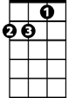

Am

C



Without your sweet love

**F E7 G7**

What would life be

**C G7**

So never ever leave me lonely

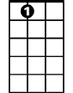

E7

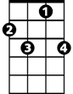

C7



F

**Am Em**

Tell me you love me only

**F C**

And that you'll always

**F C C7**

Let it be me

**(Reprise and last verse; play last line slowly)**