**Levon (Elton John / Bernie Taupin) Key C**

**Intro: C F (4X)**

**C F C**

Levon wears his war wound like a crown.

**F C**

He calls his child Jesus -

**G Am**

`Cause he likes the name

**Em7 F Dm**

And he sends him to the finest school in town

**C F C**

And Levon, Levon likes his money

**F C**

He makes a lot they say -

**G Am**

Spends his days counting

**Em7 F Dm**

In a garage by the mo-torway

**Reprise:**

**Em7 Am**

He was born a pauper to a pawn

**F**

On a Christmas day

**C Dm**

When the New York Times said God is dead

**C**

And the war's begun

F



C

**F C Dm**

Alvin Tostig has a son today

**Chorus:**

**TACET F**

And he shall be Levon

**C**

And he shall be a good man

**BARITONE**

**F**

And he shall be Levon

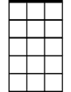

Em7



G

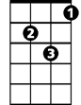

Dm

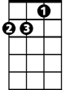

Am



F

C



**C**

In tradition with the family plan

**F**

And he shall be Levon

**C**

and he shall be a good man

**F G**

He shall be Le - von

**C F C F**

**C F C**

Levon sells cartoon balloons in town

**F C**

His family business thrives –

**G Am**

Jesus blows up balloons all day

**Em7 F Dm**

Sits on the porch swing watching them fly

**C F C**

And Jesus, he wants to go to Venus

**F C**

Leaving Levon far behind -

**G Am**

Take a balloon and go sailing

**Em7 F Dm**

While Levon, Le von slowly dies

**(Reprise)**

**(Chorus) 2x**

**C F C F (repeat to fade)**



G

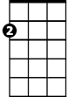

Am

Em7

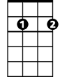

Dm

**Levon (Elton John / Bernie Taupin) Key F**

**Intro: F Bb (4X)**

**F Bb F**

Levon wears his war wound like a crown.

**Bb F**

He calls his child Jesus -

**C Dm**

`Cause he likes the name

**Am7 Bb Gm**

And he sends him to the finest school in town

**F Bb F**

And Levon, Levon likes his money

**Bb F**

He makes a lot they say -

**C Dm**

Spends his days counting

**Am7 Bb Gm**

In a garage by the mo-torway

**Reprise:**

**Am7 Dm**

He was born a pauper to a pawn

**Bb**

On a Christmas day

**F Gm**

When the New York Times said God is dead

**F**

And the war's begun



Bb

**Bb F Gm**

Alvin Tostig has a son today

**Chorus:**

**TACET Bb**

And he shall be Levon

**F**

And he shall be a good man

**BARITONE**

**Bb**

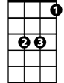

Bb



F

And he shall be Levon

**F**

In tradition with the family plan

**Bb**

And he shall be Levon

**F**

and he shall be a good man

**Bb C**

He shall be Le - von

**F Bb F Bb**

**F Bb F**

Levon sells cartoon balloons in town

**Bb F**

His family business thrives –

**C Dm**

Jesus blows up balloons all day

**Am7 Bb Gm**

Sits on the porch swing watching them fly

**F Bb F**

And Jesus, he wants to go to Venus

**Bb F**

Leaving Levon far behind -

**C Dm**

Take a balloon and go sailing

**Am7 Bb Gm**

While Levon, Le von slowly dies

**(Reprise)**

**(Chorus) 2x**

**F Bb F Bb (repeat to fade)**



C



Dm



Am7

F



Gm

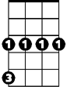

Gm

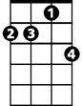

Am7



Dm

C



**Levon (Elton John / Bernie Taupin) Key G**

**Intro: G C (4X)**

**G C G**

Levon wears his war wound like a crown.

**C G**

He calls his child Jesus -

**D Em**

`Cause he likes the name

**Bm7 C Am**

And he sends him to the finest school in town

**G C G**

And Levon, Levon likes his money

**C G**

He makes a lot they say -

**D Em**

Spends his days counting

**Bm7 C Am**

In a garage by the mo-torway

**Reprise:**

**Bm7 Em**

He was born a pauper to a pawn

**C**

On a Christmas day

**G Am**

When the New York Times said God is dead

**G**

And the war's begun



C



G

**C G Am**

Alvin Tostig has a son today

**Chorus:**

**TACET C**

And he shall be Levon

**G**

And he shall be a good man

**BARITONE**

**C**

And he shall be Levon



G

C



**G**

In tradition with the family plan

**C**

And he shall be Levon

**G**

and he shall be a good man

**C D**

He shall be Le – von

**G C G C**

**G C G**

Levon sells cartoon balloons in town

**C G**

His family business thrives –

**D Em**

Jesus blows up balloons all day

**Bm7 C Am**

Sits on the porch swing watching them fly

**G C G**

And Jesus, he wants to go to Venus

**C G**

Leaving Levon far behind -

**D Em**

Take a balloon and go sailing

**Bm7 C Am**

While Levon, Le von slowly dies

**(Reprise)**

**(Chorus) 2x**

**G C G C (repeat to fade)**

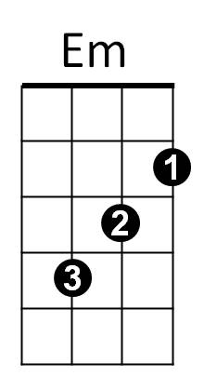

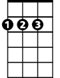

D

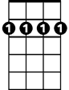

Bm7



Am



Em

Bm7



Am



D