**Life's Railway to Heaven (M.E. Abbey / Charlie Tillman / Jesse Randall Baxter) Key C**

**C C7**

Life is like a mountain railroad



C

**F C**

With an engineer that's brave

We must make the run successful

**D7 G7**

From the cradle to the grave

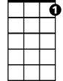

C7

**C C7**

Watch the curves the hills and tunnels

**F C**

Never falter never fail

Keep your hand upon the throttle

F



**G7 C**

And your eyes upon the rail

**Chorus:**

**C7 F C**

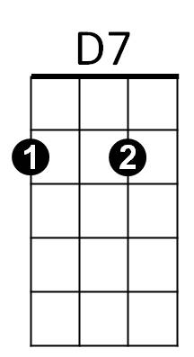Blessed Savior Thou will guide us

**G7**

Till we reach that blissful shore

**C F**

Where the angels wait to join us

**C G7 C**

In Thy praise for ever-more

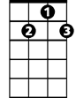

G7

**C C7**

You will roll up grades of trial

**F C**

You will cross the bridge of strife

See that Christ is your conductor

**D7 G7**

On this lightning train of life

**C C7**

Always mindful of obstructions

**F C**

Do your duty never fail

C



Keep your hand upon the throttle

**G7 C**

And your eyes upon the rail

**(Chorus)**

**C C7**

You will often find obstructions

**F C**

Look for storms of wind and rain

On a fill or curve or trestle

**D7 G7**

They will almost ditch your train

**C C7**

Put your trust alone in Jesus

**F C**

Never falter never fail

Keep your hand upon the throttle

**G7 C**

And your eyes upon the rail

**(Chorus)**

**C C7**

As you roll across the trestle

**F C**

Spanning Jordan’s swelling tide

You behold the Union Depot

**D7 G7**

Into which your train will glide

**C C7**

There you’ll meet the Superintendent

**F C**

God the Father God the Son

With the hearty joyous plaudit

**G7 C**

Weary pilgrim welcome home

**(Chorus)**

**BARITONE**



G7

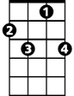

C7



F



D7

**Life's Railway to Heaven (M.E. Abbey / Charlie Tillman / Jesse Randall Baxter) Key G**

**G G7**



G

Life is like a mountain railroad

**C G**

With an engineer that's brave

We must make the run successful

**A7 D7**



G7

From the cradle to the grave

**G G7**

Watch the curves the hills and tunnels

**C G**

Never falter never fail



C

Keep your hand upon the throttle

**D7 G**

And your eyes upon the rail

**Chorus:**

**G7 C G**

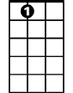

A7

Blessed Savior Thou will guide us

**D7**

Till we reach that blissful shore

**G C**

Where the angels wait to join us

 **G D7 G**

In Thy praise for ever-more

**G G7**

You will roll up grades of trial

**C G**

You will cross the bridge of strife

See that Christ is your conductor

**A7 D7**

On this lightning train of life

**G G7**

Always mindful of obstructions

**C G**

**BARITONE**

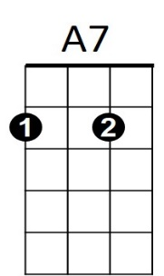Do your duty never fail



G



G7

C



D7

Keep your hand upon the throttle

**D7 G**

And your eyes upon the rail

**(Chorus)**

**G G7**

You will often find obstructions

**C G**

Look for storms of wind and rain

On a fill or curve or trestle

**A7 D7**

They will almost ditch your train

**G G7**

Put your trust alone in Jesus

**C G**

Never falter never fail

Keep your hand upon the throttle

**D7 G**

And your eyes upon the rail

**(Chorus)**

**G G7**

As you roll across the trestle

**C G**

Spanning Jordan’s swelling tide

You behold the Union Depot

**A7 D7**

Into which your train will glide

**G G7**

There you’ll meet the Superintendent

**C G**

God the Father God the Son

With the hearty joyous plaudit

**D7 G**

Weary pilgrim welcome home

**(Chorus)**