Light My Fire (Van Morrison) (Dm)

Intro: C Bm G Em / C Bm G Em / C Bm Esus4 E  Dm7 Gmaj7  You know that it would be un-true  Dm7 Gmaj7  You know that I would be a liar  Dm7 Gmaj7  If I were to say to you  Dm7 Gmaj7  Girl, we couldn't get much higher  Chorus  C Bm G Em  Come on baby light my fire  C Bm G Em  Come on baby light my fire  C Bm Esus4 E  Try to set the night on fire  Dm7 Gmaj7  The time to hesitate is through  Dm7 Gmaj7  No time to wallow in the mire  Dm7 Gmaj7  Try now we can only lose  Dm7 Gmaj7  And our love become a funeral pyre. Chorus  Repeat entire song  Outro:  C Bm Esus4 E  Try to set the night on fire (Repeat to fade) |  |  |  |  |  |  |  | 
 |  |  |  |  |  |  |  | 
 |  |  |  |  |  |  | 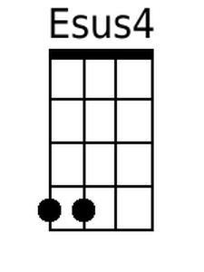 | 
 |  |  |  |  |  |  |  | 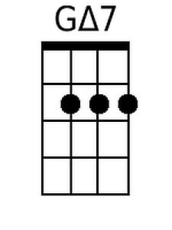
Bari
C | Bm | G | Em
Esus4 | E | Dm7 | Gmaj7

Light My Fire (Van Morrison) (Gm)

Intro: F Em C Am / F Em C Am / F Em Asus4 A  Gm7 Cmaj7  You know that it would be un-true  Gm7 Cmaj7  You know that I would be a liar  Gm7 Cmaj7  If I were to say to you  Gm7 Cmaj7  Girl, we couldn't get much higher  Chorus  F Em C Am  Come on baby light my fire  F Em C Am  Come on baby light my fire  F Em Asus4 A  Try to set the night on fire  Gm7 Cmaj7  The time to hesitate is through  Gm7 Cmaj7  No time to wallow in the mire  Gm7 Cmaj7  Try now we can only lose  Gm7 Cmaj7  And our love become a funeral pyre. Chorus  Repeat entire song  Outro:  F Em Asus4 A  Try to set the night on fire (Repeat to fade) |  |  |  |  |  |  | 
 |  |  |  |  |  |  |  | 
 |  |  |  |  |  |  | 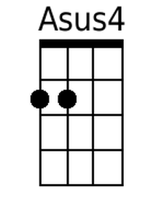 | 
 |  |  |  |  |  |  |  | 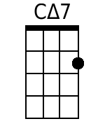
Bari
F | Em | C | Am
Asus4 | A | Gm7 | Cmaj7

Light My Fire (Van Morrison) (Bm)

Intro: A G#m E C#m / A G#m E C#m / A G#m C#sus4 C#  Bm7 Emaj7  You know that it would be un-true  Bm7 Emaj7  You know that I would be a liar  Bm7 Emaj7  If I were to say to you  Bm7 Emaj7  Girl, we couldn't get much higher  Chorus  A G#m E C#m  Come on baby light my fire  A G#m E C#m  Come on baby light my fire  A G#m C#sus4 C#  Try to set the night on fire  Bm7 Emaj7  The time to hesitate is through  Bm7 Emaj7  No time to wallow in the mire  Bm7 Emaj7  Try now we can only lose  Bm7 Emaj7  And our love become a funeral pyre. Chorus  Repeat entire song  Outro:  A G#m C#sus4 C#  Try to set the night on fire (Repeat to fade) |  |  |  |  |  |  |  | G#m
 |  |  |  |  |  |  |  | C#m
 |  |  |  |  |  |  | C#sus4 | C#
 |  |  |  |  |  |  | Bm7 | Emaj7
Bari
A | G#m | E | C#m
C#sus4 | C# | Bm7 | Emaj7

Light My Fire (Van Morrison) (Am)

Intro: G F#m D Bm / G F#m D Bm / G F#m Bsus4 B  Am7 Dmaj7  You know that it would be un-true  Am7 Dmaj7  You know that I would be a liar  Am7 Dmaj7  If I were to say to you  Am7 Dmaj7  Girl, we couldn't get much higher  Chorus  G F#m D Bm  Come on baby light my fire  G F#m D Bm  Come on baby light my fire  G F#m Bsus4 B  Try to set the night on fire  Am7 Dmaj7  The time to hesitate is through  Am7 Dmaj7  No time to wallow in the mire  Am7 Dmaj7  Try now we can only lose  Am7 Dmaj7  And our love become a funeral pyre. Chorus  Repeat entire song  Outro:  G F#m Bsus4 B  Try to set the night on fire (Repeat to fade) |  |  |  |  |  |  |  | 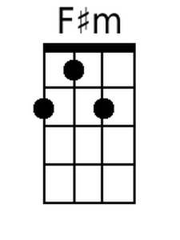
 |  |  |  |  |  |  | 
 |  |  |  |  |  |  | 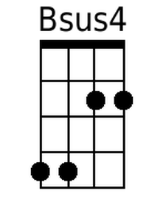 | 
 |  |  |  |  |  |  |  | 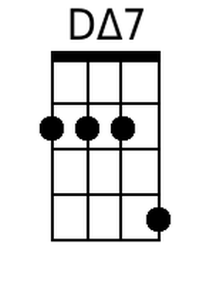
Bari
G | F#m | D | Bm
Bsus4 | B | Am7 | Dmaj7

Light My Fire (Van Morrison) (Em)

Intro: D C#m A F#m / D C#m A F#m / D C#m F#sus4 F#  Em7 Amaj7  You know that it would be un-true  Em7 Amaj7  You know that I would be a liar  Em7 Amaj7  If I were to say to you  Em7 Amaj7  Girl, we couldn't get much higher  Chorus  D C#m A F#m  Come on baby light my fire  D C#m A F#m  Come on baby light my fire  D C#m F#sus4 F#  Try to set the night on fire  Em7 Amaj7  The time to hesitate is through  Em7 Amaj7  No time to wallow in the mire  Em7 Amaj7  Try now we can only lose  Em7 Amaj7  And our love become a funeral pyre. Chorus  Repeat entire song  Outro:  D C#m F#sus4 F#  Try to set the night on fire (Repeat to fade) |  |  |  |  |  |  |  | 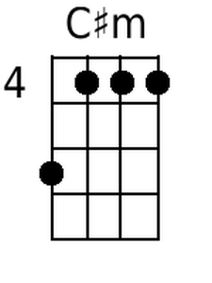
 |  |  |  |  |  |  | 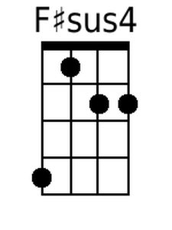 | 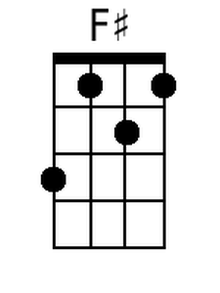
 |  |  |  |  |  |  | 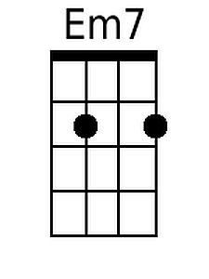 | 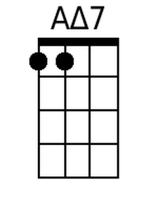
Bari
D | C#m | A | F#m
F#sus4 | F# | Em7 | Amaj7

