Light My Fire (Van Morrison) (Dm)

Intro: C Bm G Em / C Bm G Em / C Bm Esus4 E  Dm7 Gmaj7  You know that it would be un-true  Dm7 Gmaj7  You know that I would be a liar  Dm7 Gmaj7  If I were to say to you  Dm7 Gmaj7  Girl, we couldn't get much higher  Chorus  C Bm G Em  Come on baby light my fire  C Bm G Em  Come on baby light my fire  C Bm Esus4 E  Try to set the night on fire  Dm7 Gmaj7  The time to hesitate is through  Dm7 Gmaj7  No time to wallow in the mire  Dm7 Gmaj7  Try now we can only lose  Dm7 Gmaj7  And our love become a funeral pyre. Chorus  Repeat entire song  Outro:  C Bm Esus4 E  Try to set the night on fire (Repeat to fade) |  |  |  |  |  |  | 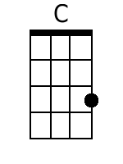 | 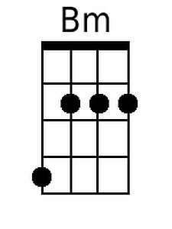
 |  |  |  |  |  |  | 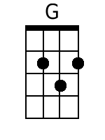 | 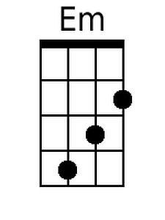
 |  |  |  |  |  |  | 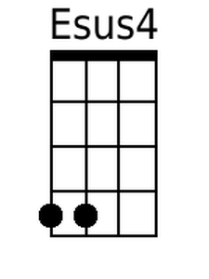 | 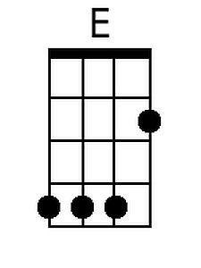
 |  |  |  |  |  |  | 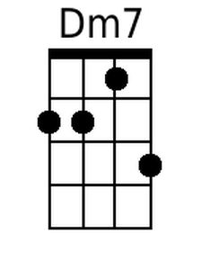 | 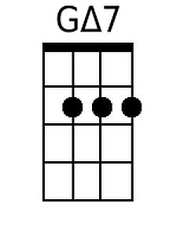
Bari
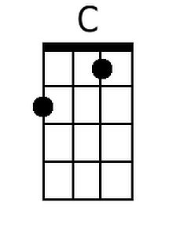 | 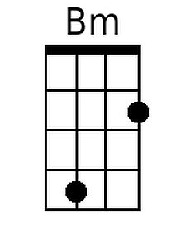 | 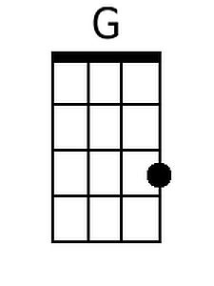 | 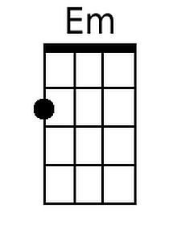
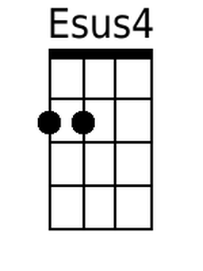 | 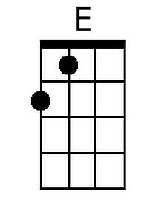 | 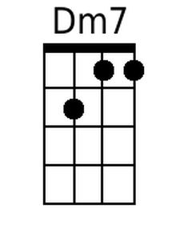 | 