**Light My Fire (Van Morrison)**

**Intro: F Em C Am / F Em C Am / F Em Asus4 A**

Em

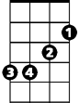

F

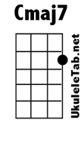

Cmaj7

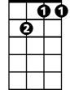

Gm7

**Gm7 Cmaj7**

You know that it would be untrue

**Gm7 Cmaj7**

You know that I would be a liar

**Gm7 Cmaj7**

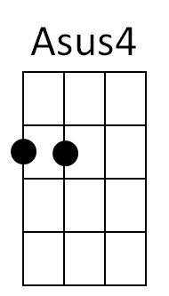If I were to say to you

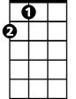

A

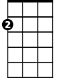

Am



C

**Gm7 Cmaj7**

Girl, we couldn't get much higher

**Chorus**

**F Em C Am**

Come on baby light my fire

**F Em C Am**

Come on baby light my fire

**F Em Asus4 A**

**BARITONE**

Try to set the night on fire

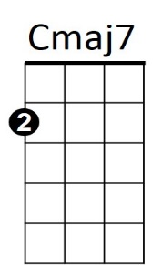



F



Em

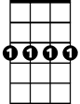

Gm7

**Gm7 Cmaj7**

The time to hesitate is through

**Gm7 Cmaj7**

No time to wallow in the mire

**Gm7 Cmaj7**

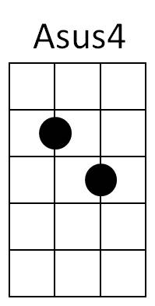Try now we can only lose

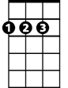

A

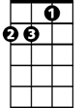

Am

C



**Gm7 Cmaj7**

And our love become a funeral pyre

**(Chorus)**

**Repeat entire song**

**Outro:**

**F Em Asus4 A**

Try to set the night on fire **(Repeat to fade)**