Lil Red Riding Hood (J.P. Richardson) (Am)

Spoken OWOOO Who do I see walking in these woods? It’s Little Red Riding Hood!

Am C  Hey there, Little Red Riding Hood  Dm  You sure are lookin' good  F E7 Am  You're everything a big bad wolf could want  E7  Oh, Listen to me!  Am C  Little Red Riding Hood  Dm  I don't think little big girls should  F E7 Am  Go walkin' in these spooky old woods alone  E7  Owwww!  C  What big eyes you have  Am  The kind of eyes that drive wolves mad  Dm  So just to see that you don't get chased  G7  I think I ought to walk with you for a ways  C  What cool lips you have  Am  They're sure to lure someone bad  Dm  So until you get to Grandma's place  G7  I think you ought to walk with me and be safe  Am C  I'm gonna keep my sheep suit on  Dm  Till I'm sure that you've been shown |  |  |  | F E7 Am  That I can be trusted walkin' with you alone  E7  Owwww!  Am C  Little Red Riding Hood,  Dm  I'd like to hold you if I could  F E7 Am  But you might think I'm a big bad wolf, so I won't  E7  Owwww!  C  What a big heart I have  Am  The better to love you with  Dm  Little Red Riding Hood  G7  Even bad wolves can be good  C  I'll try to keep satisfied  Am  Just to walk close by your side  Dm  Maybe you'll see things my way  G7  Before we get to Grandma's place  Am C  Little Red Riding Hood  Dm  You sure are lookin' good  F E7 Am  You're everything a big bad wolf could want  E7 Am C Dm F E7 Am  Owwww -- I mean a baaad - - baaad
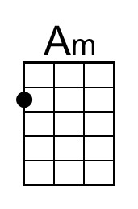 | 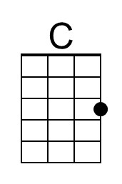 | 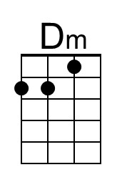 | 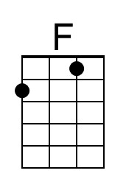 | 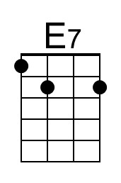 | 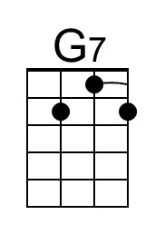
 | Bari | 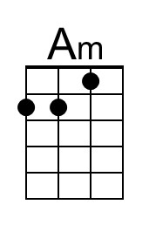 | 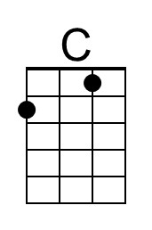 | 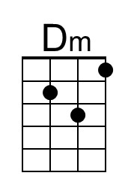 | 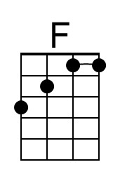 | 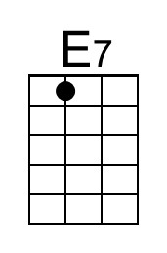 | 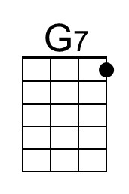

Lil Red Riding Hood (J.P. Richardson) (Em)

Spoken OWOOO Who do I see walking in these woods? It’s Little Red Riding Hood!

Em G  Hey there, Little Red Riding Hood  Am  You sure are lookin' good  C B7 Em  You're everything a big bad wolf could want  B7  Oh, Listen to me!  Em G  Little Red Riding Hood  Am  I don't think little big girls should  C B7 Em  Do walkin' in these spooky old woods alone  B7  Owwww!  G  What big eyes you have  Em  The kind of eyes that drive wolves mad  Am  So just to see that you don't get chased  D7  I think I ought to walk with you for a ways  G  What cool lips you have  Em  They're sure to lure someone bad  Am  So until you get to Grandma's place  D7  I think you ought to walk with me and be safe  Em G  I'm gonna keep my sheep suit on  Am  Till I'm sure that you've been shown |  |  |  | C B7 Em  That I can be trusted walkin' with you alone  B7  Owwww!  Em G  Little Red Riding Hood,  Am  I'd like to hold you if I could  C B7 Em  But you might think I'm a big bad wolf, so I won't  B7  Owwww!  G  What a big heart I have  Em  The better to love you with  Am  Little Red Riding Hood  D7  Even bad wolves can be good  G  I'll try to keep satisfied  Em  Just to walk close by your side  Am  Maybe you'll see things my way  D7  Before we get to Grandma's place  Em G  Little Red Riding Hood  Am  You sure are lookin' good  C B7 Em  You're everything a big bad wolf could want  E7 Am C Dm F E7 Am  Owwww -- I mean a baaad - - baaad
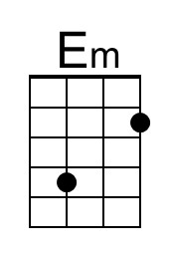 | 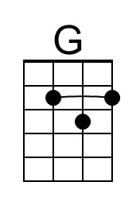 |  |  | 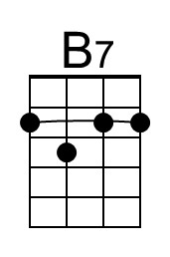 | 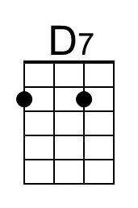
 | Bari | 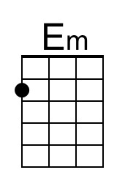 | 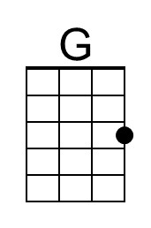 |  |  | 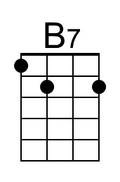 | 