**Little Red Riding Hood (J.P. Richardson)**

**Spoken:** OWOOO Who do I see walking in these woods? It’s Little Red Riding Hood!

**Am C**

Hey there, Little Red Riding Hood

**Dm**

You sure are lookin' good

**F E7 Am**

You're everything a big bad wolf could want

**E7**

Oh, Listen to me!

**Am C**

Little Red Riding Hood

**Dm**

I don't think little big girls should

**F E7 Am**

Go walkin' in these spooky old woods alone

**E7**

Owwww!

**C**

What big eyes you have

**Am**

The kind of eyes that drive wolves mad

**Dm**

So just to see that you don't get chased

**G7**

I think I ought to walk with you for a ways

**C**

What cool lips you have

**Am**

E7

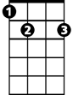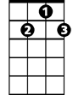

G7

F

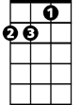

Dm

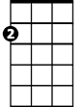

Am



C

They're sure to lure someone bad

**Dm**

So until you get to Grandma's place

**G7**

I think you ought to walk with me and be safe

**Am C**

I'm gonna keep my sheep suit on

**Dm**

Till I'm sure that you've been shown

**F E7 Am**

That I can be trusted walkin' with you alone

**E7**

Owwww!

**Am C**

Little Red Riding Hood,

**Dm**

I'd like to hold you if I could

**F E7 Am**

But you might think I'm a big bad wolf, so I won't

**E7**

Owwww!

**C**

What a big heart I have

**Am**

The better to love you with

**Dm**

Little Red Riding Hood

**G7**

Even bad wolves can be good

**C**

I'll try to keep satisfied

**Am**

Just to walk close by your side

**Dm**

Maybe you'll see things my way

**G7**

Before we get to Grandma's place

**Am C**

Little Red Riding Hood

**Dm**

You sure are lookin' good

**F E7 Am**

You're everything a big bad wolf could want

**E7 Am C Dm F E7 Am**

Owwww -- I mean a baaad - - baaad

**BARITONE**

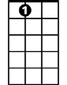

E7

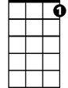

G7

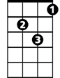

Dm



F



Am

C

