Lo, How A Rose E’er Blooming
C97 C
“Es ist ein Reis entsprungen,” 15th Century German carol, translated by Theodore Baker & Harriet Reynolds Kraugh; Music: “Es Ist Ein Ros,” Anonymous, 16th Century, harm. by Michael Praetorius

Intro Dm C-G7sus G7 C  When half spent was the night.  C F G Am F C Am G C  1. Lo, how a rose e'er bloom-ing, from tender stem hath sprung!  C F G Am F C Am G C  From Jesse’s lineage com-ing, as men of old have sung.  Dm D7 G C F G A  It came, a floweret bright, a-mid the cold of win-ter  Dm C-G7sus G7 C  When half spent was the night.  C F G Am F C Am G C  2. Isaiah 'twas fore-told it, the Rose I have in mind  C F G Am F C Am G C  With Mary we be-hold it, the Virgin moth-er kind  Dm D7 G C F G A  To show God's love a-right, she bore to us a Savior  Dm C-G7sus G7 C  When half spent was the night.  C F G Am F C Am G C  3. The shepherds heard the story, pro-claimed by angels bright,  C F G Am F C Am G C  How Christ, the Lord of Glory, was born on earth this night.  Dm D7 G C F G A  To Bethlehem they sped, and in the manger found him,  Dm C-G7sus G7 C  As angel her - alds said.  C F G Am F C Am G C  4. This Flower, whose fragrance tender, with sweetness fills the air,  C F G Am F C Am G C  Dis-pels with glorious splendor, the darkness ev - ery-where;  Dm D7 G C F G A  True man, yet very God; from Sin and death he saves us,  Dm C-G7sus G7 C  And lightens ev - ery load. |  |  |  |  |  |  |  | 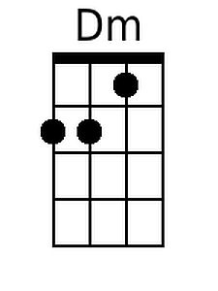 | 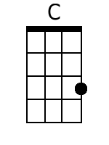
 |  |  |  |  |  |  |  | 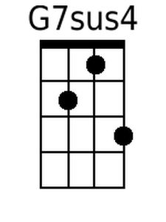 | 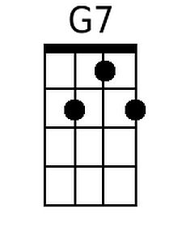
 |  |  |  |  |  |  |  | 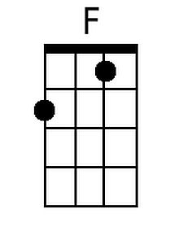 | 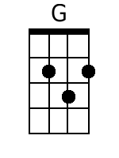
 |  |  |  |  |  |  |  | 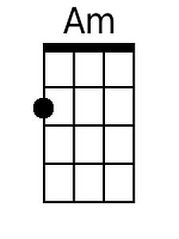 | 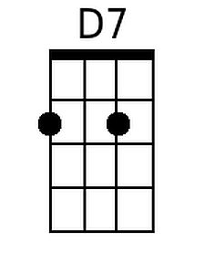
 |  |  |  |  |  |  |  | 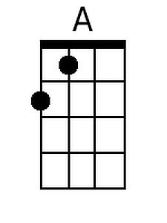
Baritone
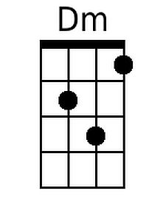 | 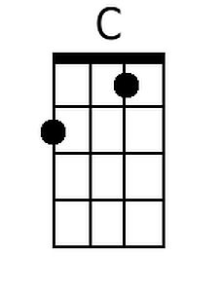 | 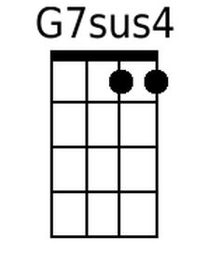 | 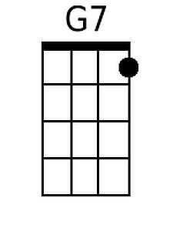 | 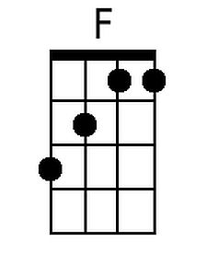 | 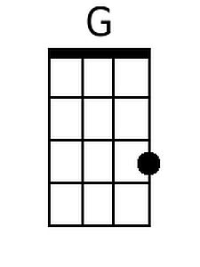 | 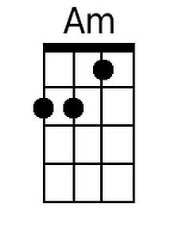 | 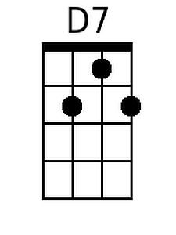 |  | 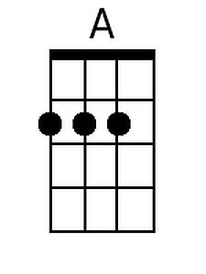

Lo, How A Rose E’er Blooming
C97 G
“Es ist ein Reis entsprungen,” 15th Century German carol, translated by Theodore Baker & Harriet Reynolds Kraugh; Music: “Es Ist Ein Ros,” Anonymous, 16th Century, harm. by Michael Praetorius

Intro Am G-D7sus D7 G
When half spent was the night.

G C D Em C G Em D G
1. Lo, how a rose e'er bloom-ing, from tender stem hath sprung!
G C D Em C G Em D G
From Jesse's lineage com-ing, as men of old have sung.
Am A7 D G C D E
It came, a floweret bright, a-mid the cold of win-ter
Am G-D7sus D7 G
When half spent was the night.

G C D Em C G Em D G
2. Isaiah 'twas fore-told it, the Rose I have in mind
G C D Em C G Em D G
With Mary we be-hold it, the Virgin moth-er kind
Am A7 D G C D E
To show God's love a-right, she bore to us a Savior
Am G-D7sus D7 G
When half spent was the night.

G C D Em C G Em D G
3. The shepherds heard the story, pro-claimed by angels bright,
G C D Em C G Em D G
How Christ, the Lord of Glory, was born on earth this night.
Am A7 D G C D E
To Bethlehem they sped, and in the manger found him,
Am G-D7sus D7 G
As angel her - alds said.

G C D Em C G Em D G
4. This Flower, whose fragrance tender, with sweetness fills the air,
G C D Em C G Em D G
Dis-pels with glorious splendor, the darkness ev - ery-where;
Am A7 D G C D E
True man, yet very God; from Sin and death he saves us,
Am G-D7sus D7 G
And lightens ev - ery load.

 |  |  |  |  |  |  | 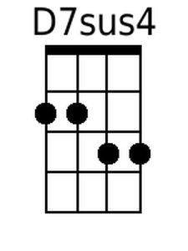 | 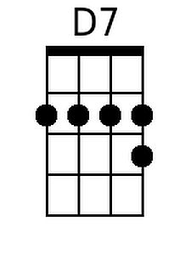
 |  |  |  |  |  |  |  | 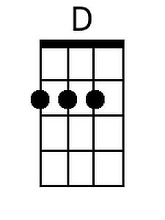
 |  |  |  |  |  |  | 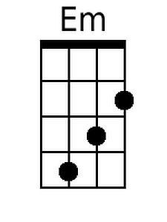 | 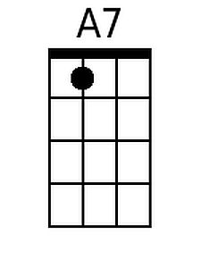
 |  |  |  |  |  |  | 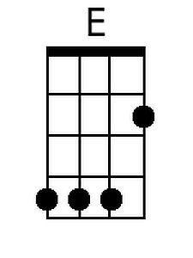
Baritone
 |  | 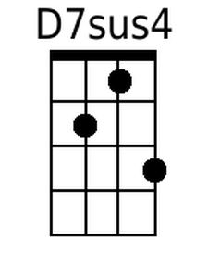 |  |  | 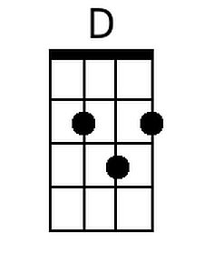 | 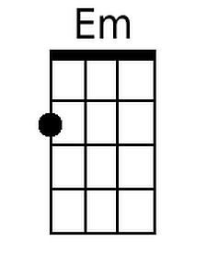 | 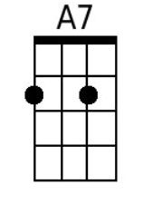 | 