Loch Lomond (Traditional) (C)

C F  By yon bonnie banks and by yon bonnie braes,  G7 C F C  Where the sun shines bright on Loch Lo - mond,  Am Em Dm F  Where me and my true love were ever wont to gae,  G7 C F C G7 C  On the bonnie, bonnie banks o' Loch Lo - mond.  Chorus  C F  O ye'll tak' the high road, and I'll tak' the low road,  C F C  And I'll be in Scotland a'fore ye,  Am Em Dm E7 F  But me and my true love will never meet a-gain,  G7 C F C G7 C  On the bonnie, bonnie banks o' Loch Lo - mond.  C F  'Twas there that we parted, in yon shady glen,  G7 C F C  On the steep, steep side o' Ben Lo - mond,  Am Em Dm F  Where in soft purple hue, the highland hills we view,  G7 C F C G7 C  And the moon coming out in the gloam-ing. Chorus  C F  The wee birdies sing and the wildflowers spring,  G7 C F C  And in sunshine the waters are sleep-ing.  Am Em Dm F  But the broken heart it kens nae second spring a-gain,  G7 C F C G7 C  Though the waeful may cease frae their griev-ing. Chorus |  |  |  |  |  |  |  | 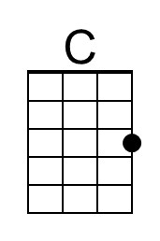
 |  |  |  |  |  |  |  | 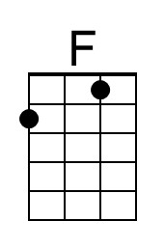
 |  |  |  |  |  |  |  | 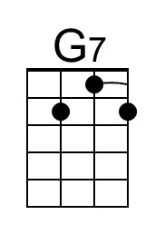
 |  |  |  |  |  |  |  | 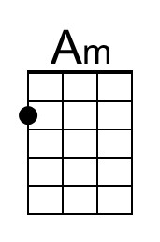
 |  |  |  |  |  |  |  | 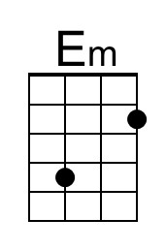
 |  |  |  |  |  |  |  | 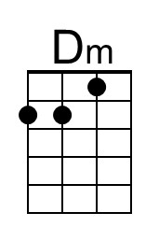
 |  |  |  |  |  |  |  | 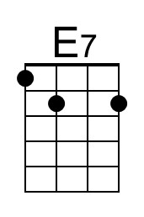
Bari | 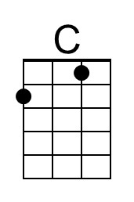 | 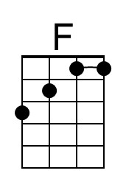 | 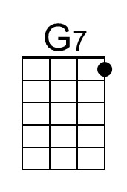 | 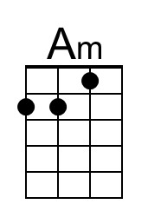 | 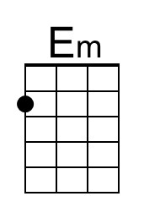 | 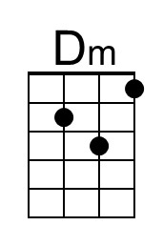 | 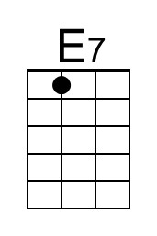

Loch Lomond (Traditional) (F)

F Bb
By yon bonnie banks and by yon bonnie braes,
C7 F Bb F
Where the sun shines bright on Loch Lo - mond,
Dm Am Gm Bb
Where me and my true love were ever wont to gae,
C7 F Bb F C7 F
On the bonnie, bonnie banks o' Loch Lo - mond.

Chorus
F Bb
O ye'll tak' the high road, and I'll tak' the low road,
F Bb F
And I'll be in Scotland a'fore ye,
Dm Am Gm A7 Bb
But me and my true love will never meet a-gain,
C7 F Bb F C7 F
On the bonnie, bonnie banks o' Loch Lo - mond.

F Bb
'Twas there that we parted, in yon shady glen,
C7 F Bb F
On the steep, steep side o' Ben Lo - mond,
Dm Am Gm Bb
Where in soft purple hue, the highland hills we view,
C7 F Bb F C7 F
And the moon coming out in the gloam-ing. Chorus

F Bb
The wee birdies sing and the wildflowers spring,
C7 F Bb F
And in sunshine the waters are sleep-ing.
Dm Am Gm Bb
But the broken heart it kens nae second spring a-gain,
C7 F Bb F C7 F
Though the waeful may cease frae their griev-ing. Chorus

 |  |  |  |  |  |  |  | 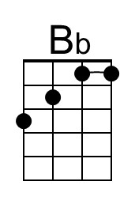
 |  |  |  |  |  |  |  | 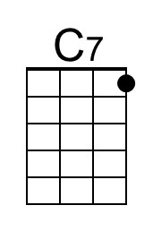
 |  |  |  |  |  |  |  | 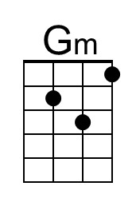
 |  |  |  |  |  |  |  | 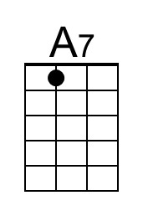
Bari |  | 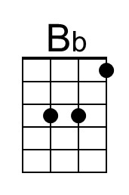 | 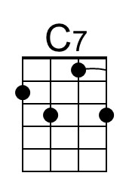 |  |  | 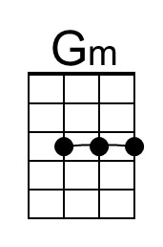 | 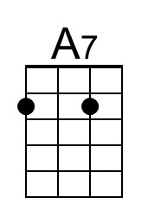

Loch Lomond (Traditional) (G)

G C  By yon bonnie banks and by yon bonnie braes,  D7 G C G  Where the sun shines bright on Loch Lo - mond,  Em Bm Am C  Where me and my true love were ever wont to gae,  D7 G C G D7 G  On the bonnie, bonnie banks o' Loch Lo - mond.  Chorus  G C  O ye'll tak' the high road, and I'll tak' the low road,  G C G  And I'll be in Scotland a'fore ye,  Em Bm Am B7 C  But me and my true love will never meet a-gain,  D7 G C G D7 G  On the bonnie, bonnie banks o' Loch Lo - mond.  G C  'Twas there that we parted, in yon shady glen,  D7 G C G  On the steep, steep side o' Ben Lo - mond,  Em Bm Am C  Where in soft purple hue, the highland hills we view,  D7 G C G D7 G  And the moon coming out in the gloam-ing. Chorus  G C  The wee birdies sing and the wildflowers spring,  D7 G C G  And in sunshine the waters are sleep-ing.  Em Bm Am C  But the broken heart it kens nae second spring a-gain,  D7 G C G D7 G  Though the waeful may cease frae their griev-ing. Chorus |  |  |  |  |  |  |  | 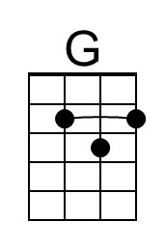
 |  |  |  |  |  |  |  | 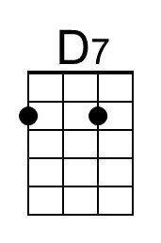
 |  |  |  |  |  |  |  | 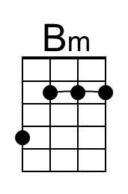
 |  |  |  |  |  |  |  | 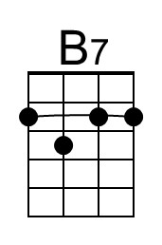
Bari | 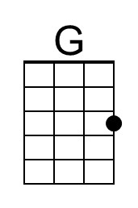 |  | 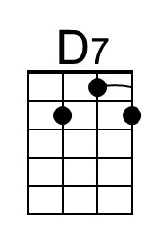 |  | 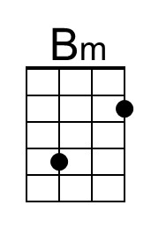 |  | 